


October 6 University Faculty of Information Systems
& Computer Sciences

Graduation Project

Rationalize the Consumption of Antibiotics System

Prepared By
Student Names Department
Mohamed Said Abdel Fattah CS
Ahmed Mohamed Ismail CS
Rady Mohamed Rady CS
Arafa Ahmed Salem IS
Ali Ahmed Ali IS
Alaa Abdullah Tawfik IS

Supervised by

Dr. Eng. Samey Elmokadem Dr. Abdelrahman El-Akhdar

Eng. Ahmed Rashad

June 2023

Abstract

Antibiotics are important drugs for the treatment of bacterial infections. However, their overuse and misuse have led to the emergence of antibiotic-resistant bacteria, which pose a significant threat to global public health.
Rationalizing the consumption of antibiotics is essential to preserve their effectiveness and ensure their availability for future generations.
We are going to achieve that through our Application and Website System that will Achieve, which involves optimizing the use of antibiotics through appropriate prescribing practices, surveillance and monitoring, and the development of alternative treatments.

Acknowledgement

We express our deep gratitude and appreciation to those who agreed to participate in this project.
First, we have to thank Prof. Nabila Mohamed Hassan faculty Dean for facilitating the educational process and making sure for providing all necessary tangible and mental basics needed for our success.
Special thanks go to Dr. Eng. Samy Elsayed El Mokadem, our supervisor in this project for supporting us throughout the year. He Was very patient toward us and acted like a real mentor when we needed him. We benefited a lot from his knowledge. And Dr. Abdelrahman El-Akhdar for his support, constant supervision, and patience, as well as Eng. Ahmed Rashad for providing necessary information regarding the project.
We highly indebted to board members of Faculty Of Pharmacy, We Would Thank Dr. Samir Othman vice Dean Of the College Of Pharmacy And Dr. Ahmed Essam for providing this opportunity for us by trusting in us and provide the project with information and complete details.
Finally, we want to thank our family members for their support and encouragement and our friends for great and helpful suggestions.

Table of Contents
Abstract ……………..……………………………………………................…………………………………………………………………..……I
Acknowledgment ………………………………………………………………………………………………………….………….……….……II
List Of Abbreviations & Glossary …………………………………………….………………………………………………………….V
List Of Figures ……………………………………………………………………………………………………………..……………………..VI
Chapter 1: Introduction
1.1 Overview 1
1.2 Problem Definition 2
1.3 Objectives 3
1.4 Stack Holder 3
1.5 Work plan 4
Chapter 2: System Analysis
2.1 Overview………………………………………………………………………………………………………..……………………………………..5
2.2 Requirements 5
2.2.1 Functional requirements 5
2.2.2 Non- Functional requirements 6
2.3 System analysis diagrams 7
2.3.1 Use Case Diagram 10
2.3.2 Data Flow Diagram 11
2.3.3 Activity Diagram 18
2.3.4 Sequence Diagram 22
Chapter 3: System Design
3.1 Overview 23
3.2 Entity Relationship Diagram 25
3.3 Schema Model 26
Chapter 4: System Implementation
4.1 Over View ………………………………………………………………………………………………………………………………..……………27
4.2 Developing tools 28
4.3 System Screen Shoots 32
4.4 Mobile Application Screen Shoots …………………………………………………………………………………………………………44

Chapter 5: Conclusion, Future Work
5.1 Conclusion ………………………………………………….…………………………….50
5.2 Future Work ………………………………………………………………………..……..50
Appendices……………………………………………………………………………………..….….51
References ……………………………………………………………………………………..….….76
List of Abbreviations & Glossary

- ERD Entity Relationship Diagram
- CSS Cascading Style Sheets
- MVC Model View Controller
- Html Hyper Text Markup Language
- JS JavaScript
- API Application Programming Interface
- DBMS Data Base Management System
- UML Unified Modeling Language
- SEO Search engine optimization

Glossary

Admin | Someone with full accessibility (permissions) who can  •Add users to system.  •Track Users Activities.  •View the consumption statistics of antibiotic.
User | Someone with minimum accessibility on the system,  the role of default user is only inserting and updating patient’s records, and his permissions can be extended as needed.
Consumption Statistics | Admin can select a specific time (exp. Weekly or monthly) where he can see a full statistics data of the antibiotic consumed during that period

Figures List

Figure (1.1) Process Model…………………………………………………………4
Figure (2.1) Use Case Diagram …………………………………………………..10
Figure (2.2) Data Flow Diagram Context level…………………………………..13
Figure (2.3) Data Flow Diagram Level 0……………………………………..…..14
Figure (2.4) Activity Diagram …………………………………………………..…18
Figure (2.5) Sequence Diagram ………………………………………….………22
Figure (2.6) Sequence Diagram……………………………………………….….23
Figure (3.1) Entity Relationship diagram…………………….………….………..25
Figure (3.2) Schema Model………………………………………….…….………26
Screen Shoots Of System…………………………………………..……32
Screen Shoots Of Mobile Application ………………………….…….…44

Chapter 1
Introduction

  - Overview

Bacteria is a very serious disease, which may cause death sometimes, and treatment of bacteria using inappropriate antibiotics causes immunodeficiency, so we aim to create a system that aims to rationalize the consumption of antibiotics, by knowing the type of bacteria in the patient, by taking a sample from The patient’s body, analysis, knowing the type of bacteria, and giving him the antibiotic that is resistant to this bacteria, and through that, the patient will take the appropriate antibiotic for him, because there are types of antibiotics that treat more than one type of bacteria, so through the correct diagnosis of the patient and knowing the bacteria that he has, he will take the antibiotic that is resistant to this bacteria, This will save money for the hospital and the patient due to the high price of antibiotics.

1.2 Problem

Each antibiotic can be used to treat more than one type of bacteria, and the doses of antibiotics required to treat a patient vary. These doses vary according to the patient’s age, gender, health condition and other factors. Therefore, it is necessary to have a system followed in the consumption of antibiotics that aims to rationalize the consumption of antibiotics in their places of distribution, whether hospitals, clinics or pharmacies.

1.3 Project Objectives:

The project aims to build a system that helps rationalize the consumption of antibiotics. The best way to rationalize consumption is to monitor the number of patients, the types of diseases they have, and the doses required for the treatment process.
1.3.1 Objectives

- Detecting if an antibiotic is being consumed inappropriately
- Setting appropriate dosage instructions for each patient, according to the case, during the patient registration process.
- Monitoring and extracting patients’ statistics at the hospital
- Monitoring and extracting statistics of antibiotic consumption in the hospital.
- Conserve time and effort.
- Injecting new technology in O6U services.
- Reduce the number of consumed antibiotics.

1.4 Stakeholders

- Faculty Of Pharmacy.

- Hospitals.

1.5 Work Plan
It’s necessary to use waterfall process model, since all requirements of the system are gathered and specified, and it gives us a space to clearly define each stage perfectly.

Process Model
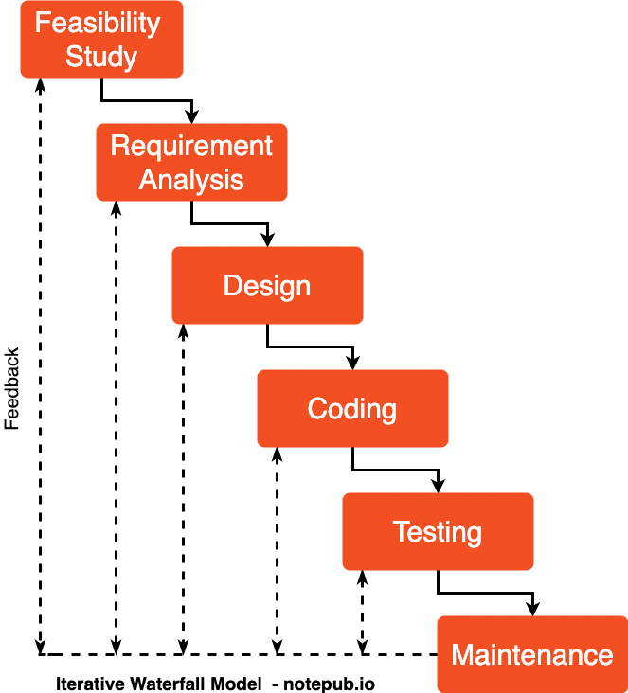

Chapter 2
System Analysis

2.1 Overview
This chapter include system analysis and design. It describes how the system works through discuss functional and non-functional requirements, Context diagram, Data Flow Diagram (DFD), Entity Relationship Diagram (ERD), etc.

2.2 Requirements:
This section discusses how the main functions work and includes its analysis to make the system clearer for reader and understand what happen.

2.2.1 functional Requirements:
A functional requirement (FR) document defines the functionality of a system or one of its subsystems. It also depends upon the type of software, expected users and the type of system where the software is used.
- Ability to register patients’ data with the type of antibiotic consumed.
- Ability to manage patients’ records.
- Ability to manage antibiotic quantity in hospital.
- Ability to manage antibiotic quantity in hospital.
- Ability to add users with different roles on the system.
- Ability to manage users and see their activities.

2.2.2 Non-functional Requirements:
A Non-Functional requirement (NFR) is a requirement that specifies criteria that can be used to judge the operation of the system, rather than specific behaviors. Non-functional requirements are often called “quality attributes” of a system. Nonfunctional requirements
such as:
- Data integrity
- System security
- System reliability
- System dependability

2.3 System analysis diagrams:
2.3.1 Use Case :
A UML use case diagram is the primary form of system/software requirements for a new software program underdeveloped. Use cases specify the expected behavior (what), and not the exact method of making it happen (how).
Components of Use case Diagram:
Actor
- Someone interacts with use case (system function).
- Actor plays a role in the business.
- Similar to the concept of user, but a user can play different roles.
- Actor has a responsibility toward the system (inputs), and Actor has expectations from the system (outputs).
- Actor triggers use case(s).
Use case  - System function (process – automated or manual)  - Each Actor must be linked to a use case, while some use cases may not be linked to actors. | 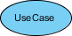
Communication Link
- The participation of an actor in a use case is shown by connecting an actor to a use case by a solid link.
- Actors may be connected to use cases by associations, indicating that the actor and the use case communicate with one another using messages.
Boundary of system  - The system boundary is potentially the entire system as defined in the requirements document.  - For large and complex systems, each module may be the system boundary.  - For example, for an ERP system for an organization, each of the modules such as personnel, payroll, accounting, etc.  - can form a system boundary for use cases specific to each of these business functions.  - The entire system can span all of these modules depicting the overall system boundary | 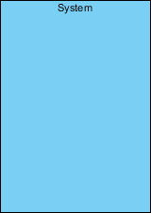
Use case Relationships  Extends  - Indicates that an “Invalid Password” use case may include (subject to specified in the extension) the behavior specified by base use case “Login Account”.  - Depict with a directed arrow having a dotted line. The tip of arrowhead points to the base use case and the child use case is connected at the base of the arrow.  - The stereotype “<<extends>>” identifies as an extend relationship  Include  - When a use case is depicted as using the functionality of another use case, the relationship between the use cases is named as include or uses relationship.  - A use case includes the functionality described in another use case as a part of its business process flow.  - An include relationship is depicted with a directed arrow having a dotted line. The tip of arrowhead points to the child use case and the parent use case connected at the base of the arrow.  - The stereotype “<<include>>” identifies the relationship as an include relationship. | 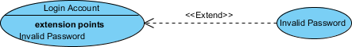  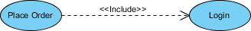

Purpose of Use Case Diagram is
- The ability to save patient records (name, age, gender, blood sample, antibiotic, antibiotic portion)
- The ability to modify patient records
- The ability to view the statistics of antibiotic consumption
- The ability to track Users activity
Use case:
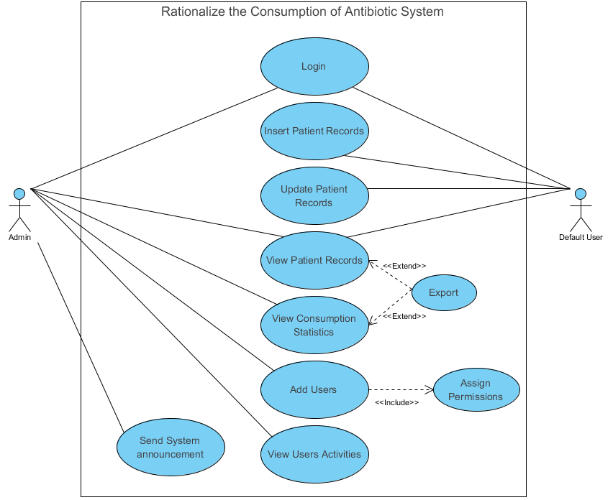

Figure (2.1) Use Case Diagram

2.3.2Dataflow Diagram :
It shows how information enters and leaves the system, what changes the information and where information is stored. The purpose of a DFD is to show the scope and boundaries of a system as a whole. It may be used as a communications tool between a systems analyst and any person who plays a part in the system that acts as the starting point for redesigning a system.
It is usually beginning with a context diagram as level 0 of the DFD diagram, a simple representation of the whole system. To elaborate further from that, we drill down to a level 1 diagram with lower-level functions decomposed from the major functions of the system. This could continue to evolve to become a level 2 diagram when further analysis is required. Progression to levels 3, 4 and so on is possible but anything beyond level 3 is not very common. Please bear in mind that the level of detail for decomposing a particular function depending on the complexity that function.
DFD Components
External Entity  An external entity can represent a human, system or subsystem. It is where certain data comes from or goes to. It is external to the system we study, in terms of the business process. For this reason, people used to draw external entities on the edge of a diagram. | 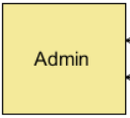
Process  A process is a business activity or function where the manipulation and transformation of data take place. A process can be decomposed to a finer level of details, for representing how data is being processed within the process. | 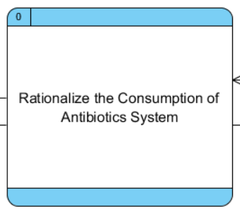
Data Store  A data store represents the storage of persistent data required and/or produced by the process. | 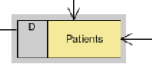
Data Flow  A data flow represents the flow of information, with its direction represented by an arrowhead that shows at the end(s) of flow connector. | 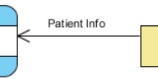

Dataflow of Rationalize the Consumption of Antibiotic System

Context Level

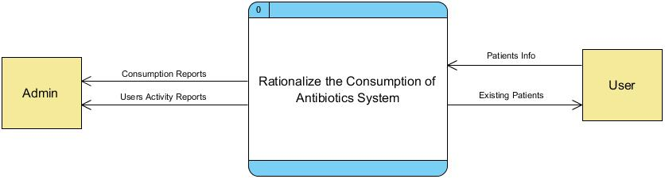

Figure (2.2) Data Flow Diagram Context level

DFD Level 1

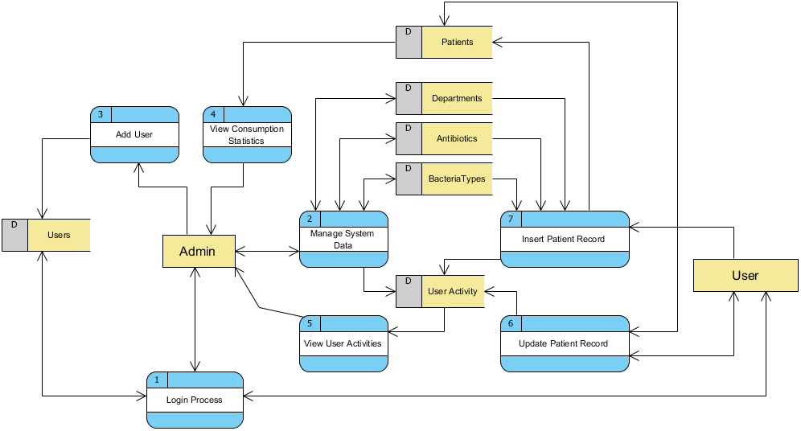

Figure (2.3) Data Flow Diagram Level 0

2.3.3 Activity Diagram
Activity Diagrams describe how activities are coordinated to provide a service which can be at different levels of abstraction. Typically, an event needs to be achieved by some operations, particularly where the operation is intended to achieve a number of different things that require coordination, or how the events in a single use case relate to one another, in particular, use cases where activities may overlap and require coordination.

Notations of Activity Diagram
Action :  A task to be performed. | 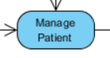
Initial Node :  Portrays the beginning of a set of actions or activities. | 
Activity Final Node :  Stop all control flows and object flows in an activity (or action) | 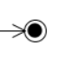
Decision Node :  Represent a test condition to ensure that the control flow or object flow only goes down one path. | 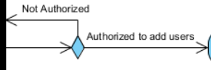
Fork Node :  Split behavior into a set of parallel or concurrent flows of activities (or actions). | 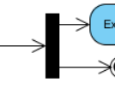
Join Node :  Bring back together a set of parallel or concurrent flows of activities (or actions). | 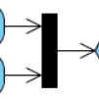

The Next Activity Diagram Describes:

- Login Activity
- Insert new patient record activity
- Update existing patient record activity
- View/Export Antibiotic Consumption Statistics
- Add new user activity
- Manage System settings (Departments, Antibiotic Types, Bacteria Types)

Activity Diagram of Rationalize the consumption of Antibiotics System
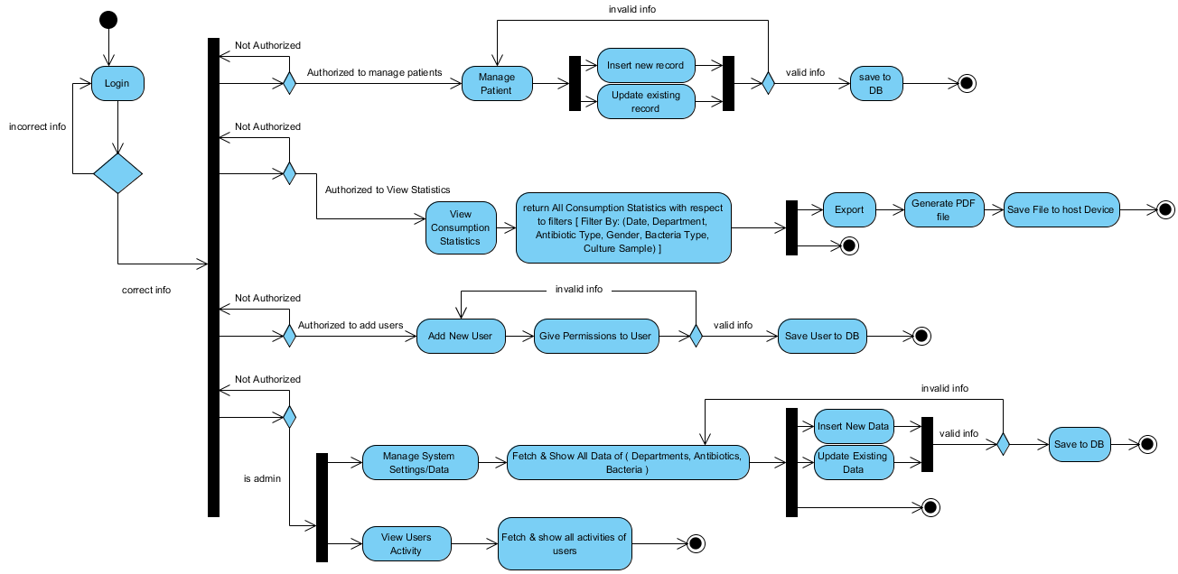
Figure (2.4) Activity Diagram
2.3.4Sequence Diagram
Sequence Diagrams are interaction diagrams that detail how operations are carried out. They capture the interaction between objects in the context of a collaboration. Sequence Diagrams are time focus and they show the order of the interaction visually by using the vertical axis of the diagram to represent time what messages are sent and when.
Components Of Sequence Diagram :
Actor:  - a type of role played by an entity that interacts with the subject  - external to the subject (i.e., in the sense that an instance of an actor is not a part of the instance of its corresponding subject).  - represent roles played by human users, external hardware, or other subjects. | 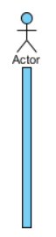
Lifeline :  - A lifeline represents an individual participant in the Interaction. | 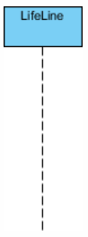
Activations :  - A thin rectangle on a lifeline) represents the period during which an element is performing an operation.  - The top and the bottom of the of the rectangle are aligned with the initiation and the completion time respectively | 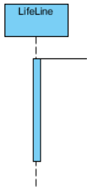
Call Message :  - Call message is a kind of message that represents an invocation of operation of target lifeline. | 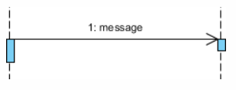
Return Message :  - Return message is a kind of message that represents the pass of information back to the caller of a corresponded former message. | 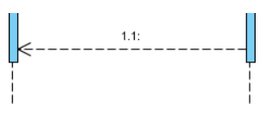
Self-Message :  - Self-message is a kind of message that represents the invocation of message of the same lifeline. | 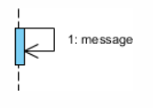
Alt Fragment :  - Alternative multiple fragments: only the one whose condition is true will execute. | 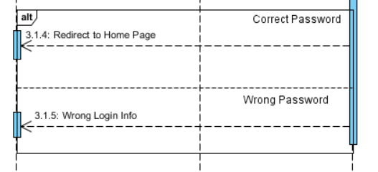

Sequence Diagram of Inserting new Patient Record
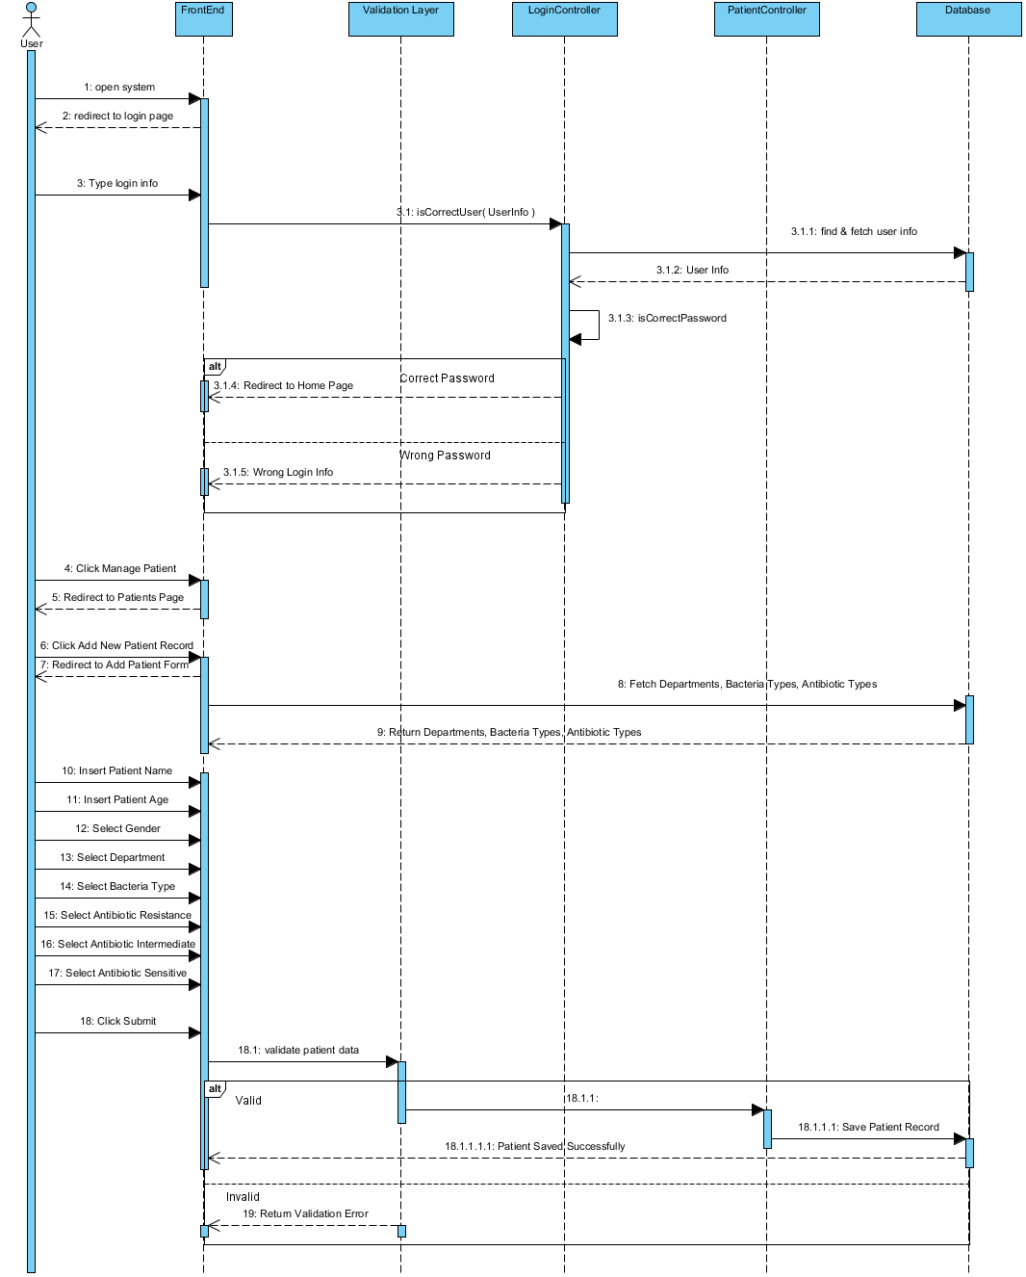
Figure (2.5) Sequence Diagram 1.0
Sequence Diagram of Viewing Antibiotics Consumption Statistics
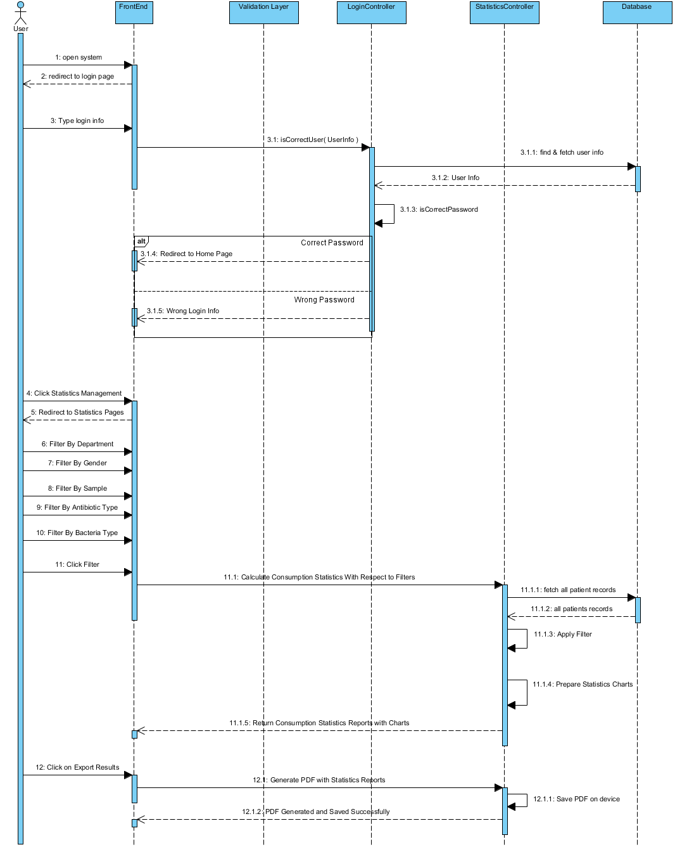
Figure (2.6) Sequence Diagram 1.1

Chapter 3
System Design

3.1 Overview
The process of defining the architecture, product design, modules, interfaces, and data for a system in order to meet specific criteria is known as systems design. The application of systems theory to product development is known as systems design. The disciplines of systems analysis, systems architecture, and systems engineering have some overlap.

3.2 Entity Relationship Diagram

The relationships between entity sets recorded in a database are depicted In an ERD An object, or a data component, is an entity in this context collection of a similar is referred to as an entity set These entities can have values defined via attributes, an ERD depicts the logical flow by defining the entities , their attributes, and the relationships between them It explains interconnected objects of interest, entity types (which classify the things of interest) and relationships (which might exist between entities) make up the foundation of an ER model.

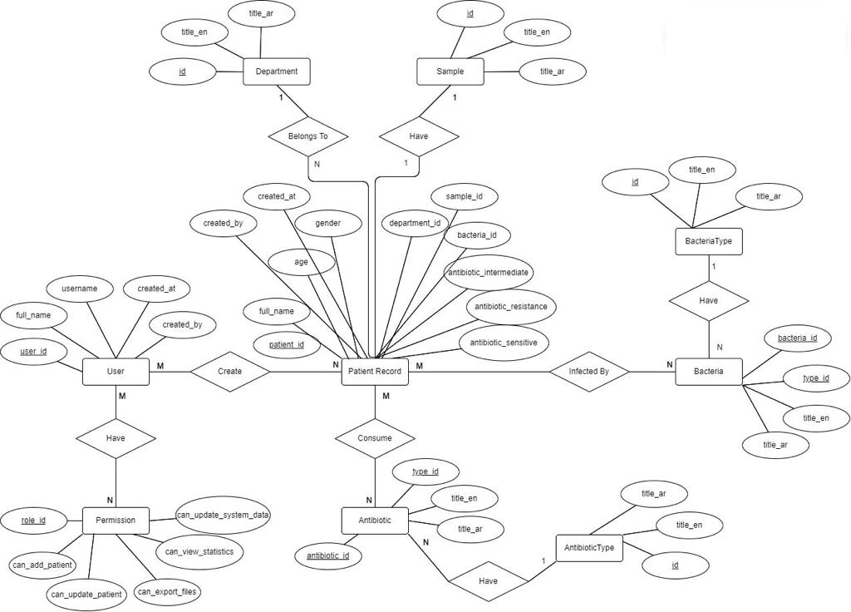

Figure (3.1) Entity Relationship Diagram
3.3 Schema Model
is a form of data model that establishes a database’s logical structure, it dictates show data may be stored, structured, and manipulated in the first place, the relational model, which uses a table-based format, is the most used database model.

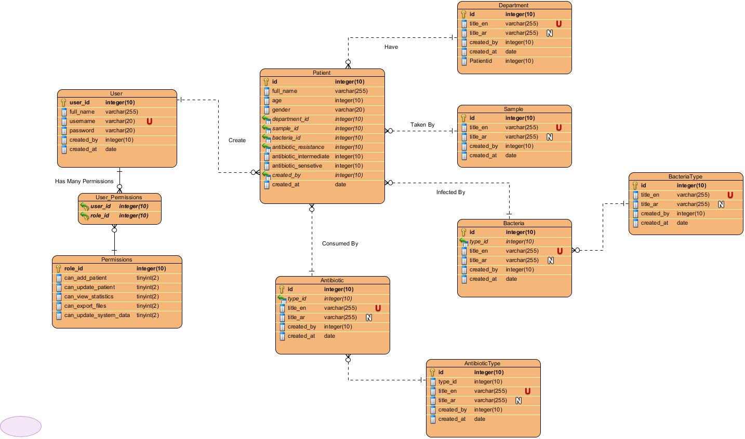

Figure (3.2) Database Model

Chapter 4
System Implementation

4.1 Overview:
This chapter will provide more detailed information about the technologies used in the project and other important information about the vision to be
clear.
4.2 Tools
With the help of high-end tools we gathered and combined we
had the opportunity to deliver and accomplish all the project
objectives in the easiest and most efficient way.
In building our website we used the following tools:
Front-end :
- html5
- css3
- JavaScript
- jQuery
- bootstrap
Back-end :
- Php
- Laravel
- My SQL
- MVC

Mobile Application:
- Flutter

4.2.1 web development:
Technology is an important aspect of our daily life. It allows us to carry out everyday chores but also making room for extraordinary ideas. During the web development process, web developers create web pages and applications for the Internet or a private network. In general, web development refers to the tasks involved in creating websites for intranet or internet hosting.

Web design, web content development, client side/server-side scripting, and network security settings are all part of the web development process. Web development, in a wide sense, refers to all of the actions, updates, and operations required to create, maintain, and administer a website in order to assure its optimal functionality, user experience, and speed.
It may also include, but is not required to, all of the strategic measures required to assure its proper ranking in search engine results. Those jobs usually fall under a different category, notably search engine optimization (SEO) tasks.

4.2.2 Front-end development:
Front-end web development, also known as client-side development, is the process of building code for a website or web application in Hyper Text Markup Language (HTML), Cascading Style Sheets (CSS), and JavaScript so that users can see and interact with it directly.
It’s important to understand the fundamental differences between front-end development, back-end development, and full stack development before diving deeper into this topic. Simply described, a front-end developer is a programmer that works on the components of an app or website that consumers view and interact with.
A back-end developer, on the other hand, is responsible for the 5 developer, on the other hand, is someone who works on the entire design process from beginning to end. Front-end development is required for various websites and web apps. Consider a single-page information website. Back-end development, on the other hand, is usually required for anything that is functional. So front-end development is responsible for everything you see on the page – and by that we mean anything that happens on the user’s computer. Back-end development encompasses anything that receives data from a server.
When an app is in use, requests are sent from the frontend (the page) to the back end (i.e. server), which subsequently sends information in plain format.
The front-end styles it before rendering it, whereas the backend is server-side programming that communicates with the database

4.2.3 Goals and challenges in front-end development:
Accessibility: This is where they ensure that everyone can easily use the website or app, regardless of their mobile device (think smartphones and tablets).
Front-end developers use this method to ensure that their site displays appropriately in all browsers and on all devices. This is accomplished utilizing CSS stylesheets and a responsive web design. •
Render time: Here, performance is measured in terms of render time. As a result, front-end developers work on the code to ensure that the site/app loads quickly.
Rapid Development: This refers to a development method that is both swift and efficient.
4.2.4 Database:
A database is an organized collection of data, generally stored and accessed electronically from a computer system. Where databases are more complex they are often developed using formal design and modeling techniques.
The database management system (DBMS) is the software that interacts with end users, applications, and the database itself to capture and analyze the data.
The DBMS software additionally encompasses the core facilities provided to administer the database. The sum total of the database, the DBMS and the associated applications can be referred to as a “database system”. Often the term “database” is also used to loosely refer to any of the DBMS, the database system or an application associated with the database.
Computer scientists may classify database-management systems according to the database models that they support. Relational databases became dominant in the 1980s.
These model data as rows and columns in a series of tables, and the vast majority use My SQL for writing and querying data. In the 2000s, non- relational databases became popular, referred to as NoSQL because they use different query languages.

4..2.5 Backend Development:
What is an API?
API is the acronym for Application Programming Interface, which is a software intermediary that allows two applications to talk to each other. Each time you use an app like Facebook, send an instant message, or check the weather on your phone, you’re using an API.
What is Python?
Python is an interpreted high-level general-purpose programming language. Its design philosophy emphasizes code readability with its use of significant indentation. Its language constructs as well as its object-oriented approach aim to help programmers write clear, logical code for small and large-scale projects

4..2.6 Mobile Application Technology
Flutter
Flutter is a mobile app development framework created by Google. It allows developers to create high-performance, visually appealing, and natively compiled applications for Android, iOS, web, and desktop platforms using a single codebase. Flutter uses Dart, a modern programming language that is easy to learn and offers features such as hot reload, which allows developers to see changes in real-time as they make modifications to the code. Flutter also provides a rich set of pre-built widgets and tools that make it easy to create complex UI designs and animations. Due to its simplicity, flexibility, and performance, Flutter has gained popularity among developers, and it is widely used to develop mobile apps for various industries, including healthcare, finance, e-commerce, and gaming.

4.3 System Screen Shoots:

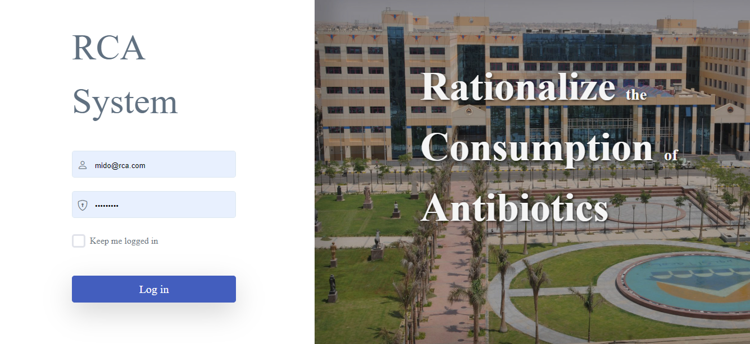

Login Page On Website

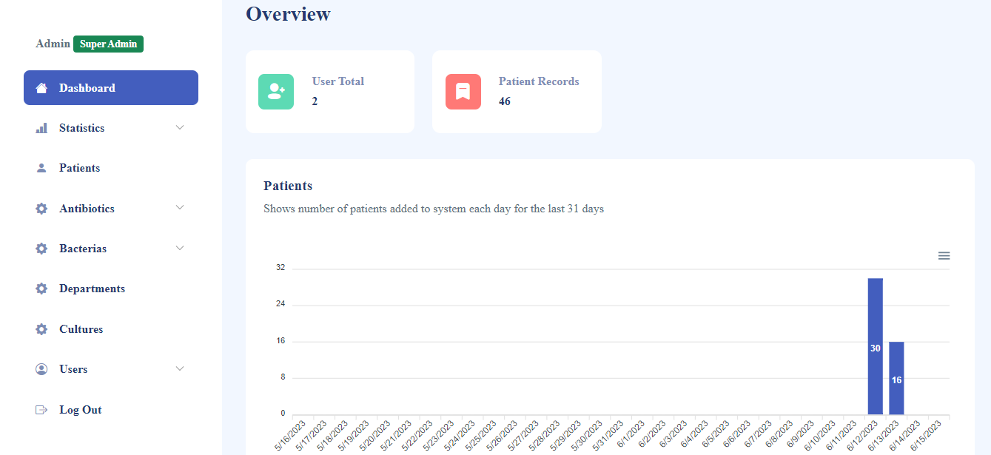

Dashboard Page
(Show Number Of Users Who Use System , And Number Of Patients
Recorded In The System)

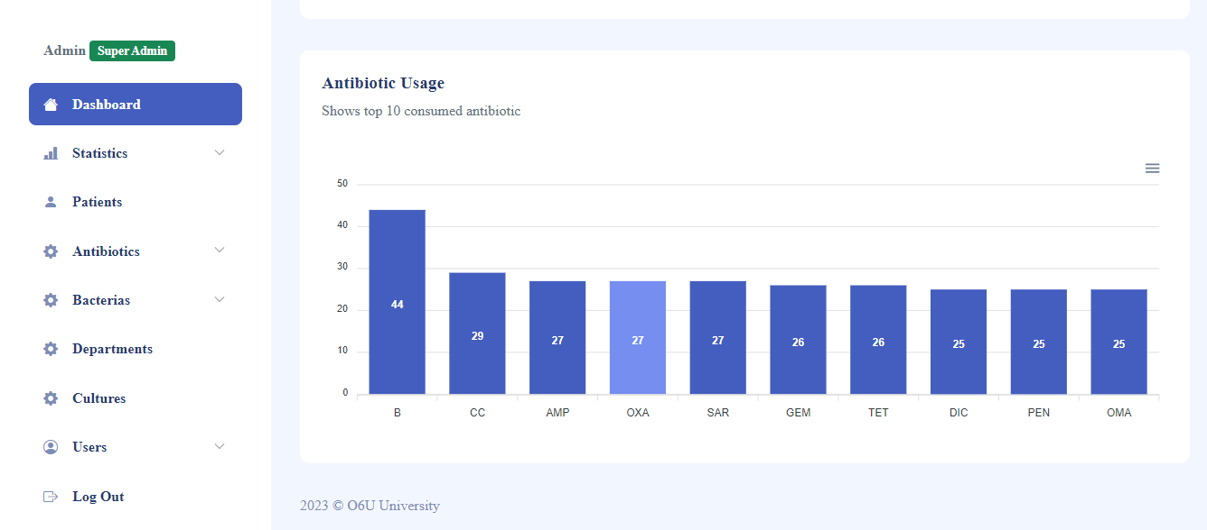

Show Top 10 Antibiotic Consumed

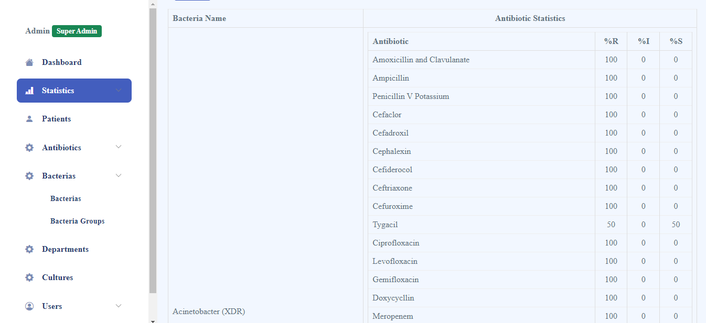

Show Bacteria And Effectiveness Of Antibiotics With It

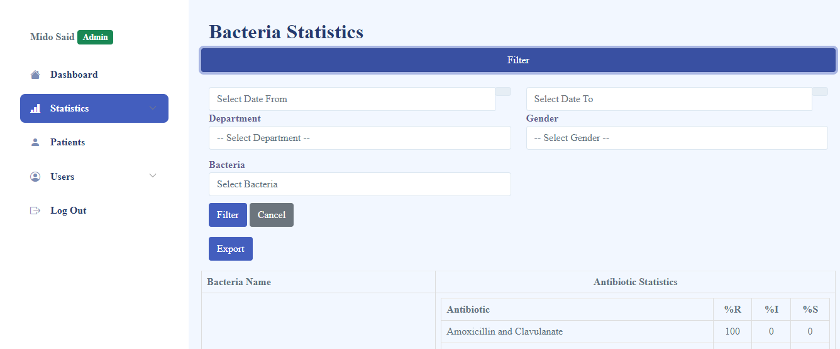

Filter Process If I Want To Search About Specific Bacteria Or Specific Period

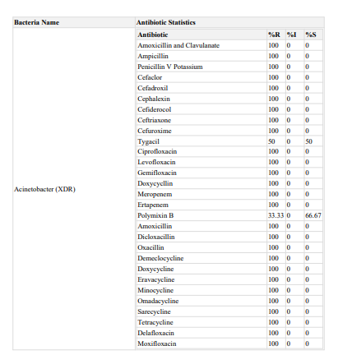

Also Can Export Result In Pdf Form Like This

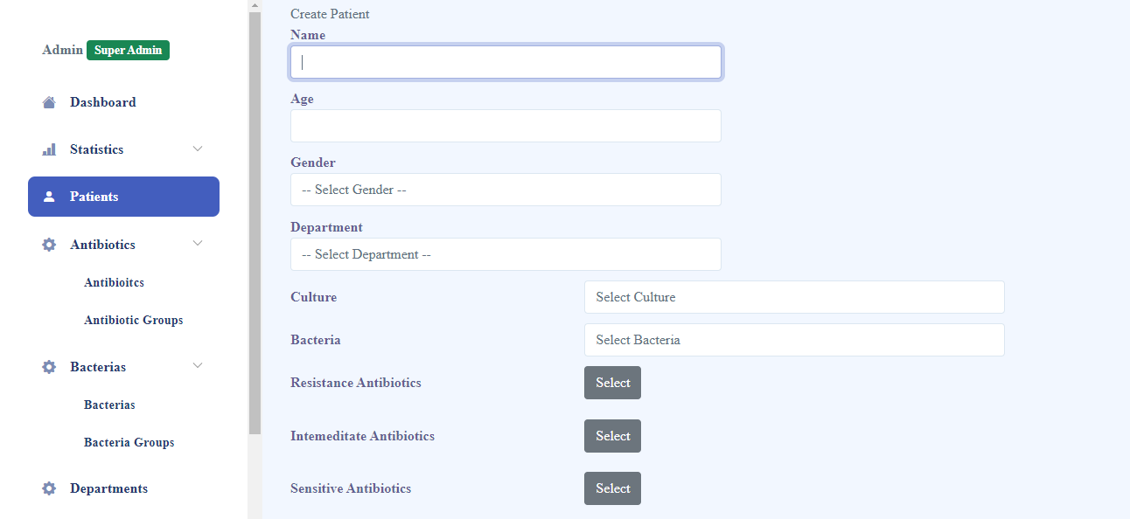

Process Of Adding New Patient

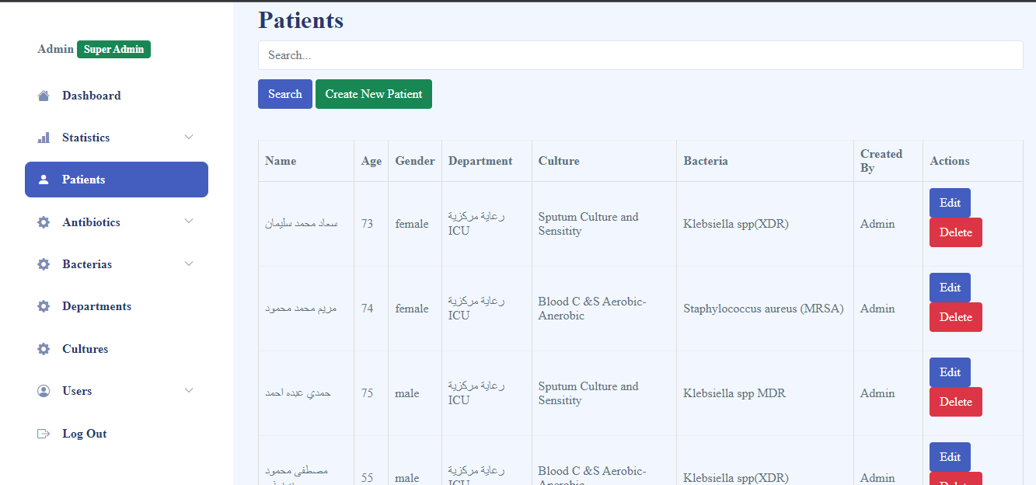

As Son As I Created Patient , Patient Record Will be Added To Patients Records , Also I Can Edit Patient Data And I Can Search About Specific Patient From Search Bar.

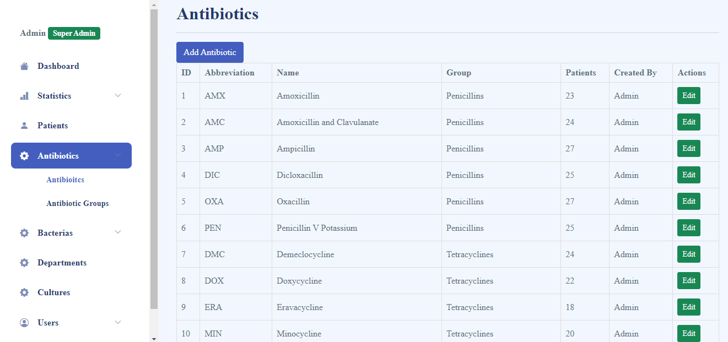

This Page Contain All Antibiotics Recorded In The System ,I Can Add New Antibiotic And I Can Update Data Of Antibiotic.

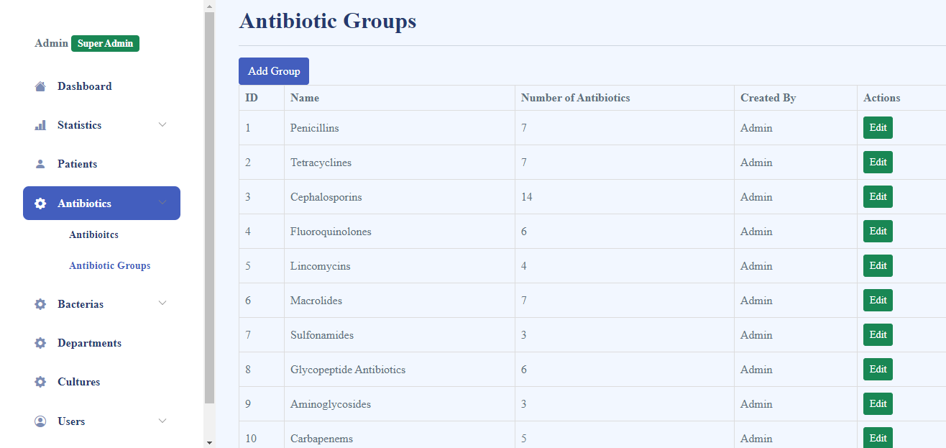

This Page Contain Groups Of Antibiotics I Can Also Add New Group ,And I Can Update Data Of Antibiotics Groups.

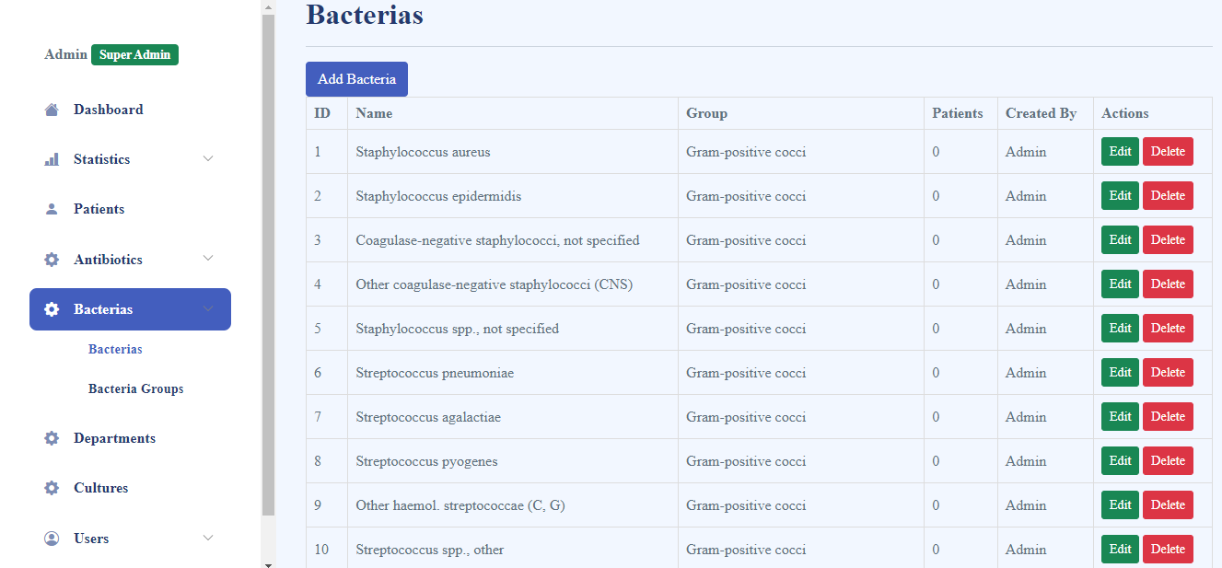

This Page Show Bacteria Name And Group Followed To And Number Of Patients Who Infected By It, Also I Can Add New Bacteria.

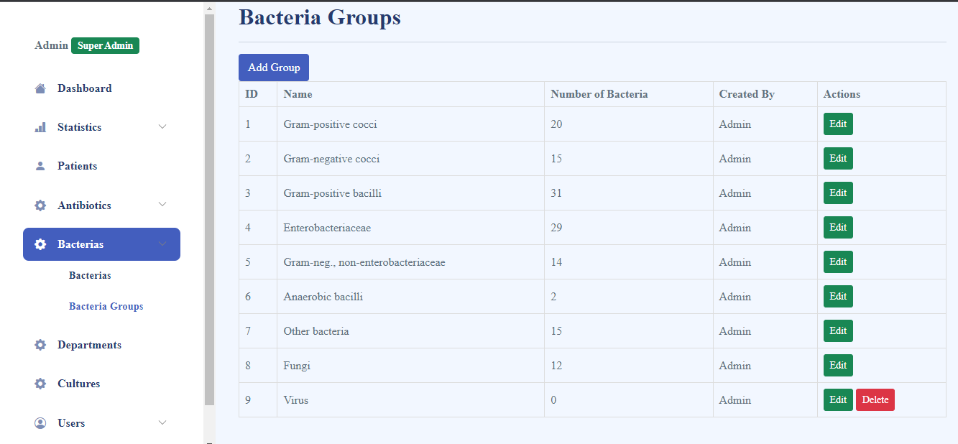

This Page Show Groups Of Bacteria, Also I Can Add New Group.

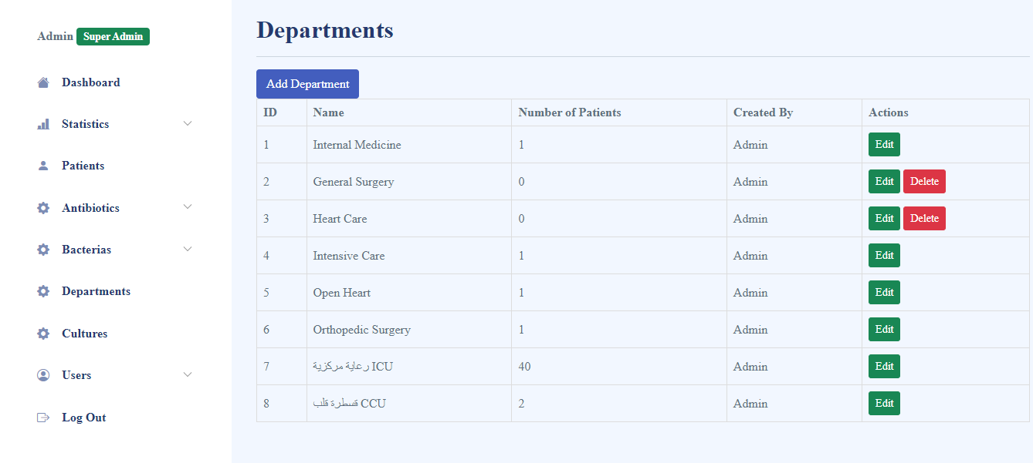

This Page Show Departments In The Hospital In Which Patient Reserved , I Can Add New Department And Update Data Of Departments.

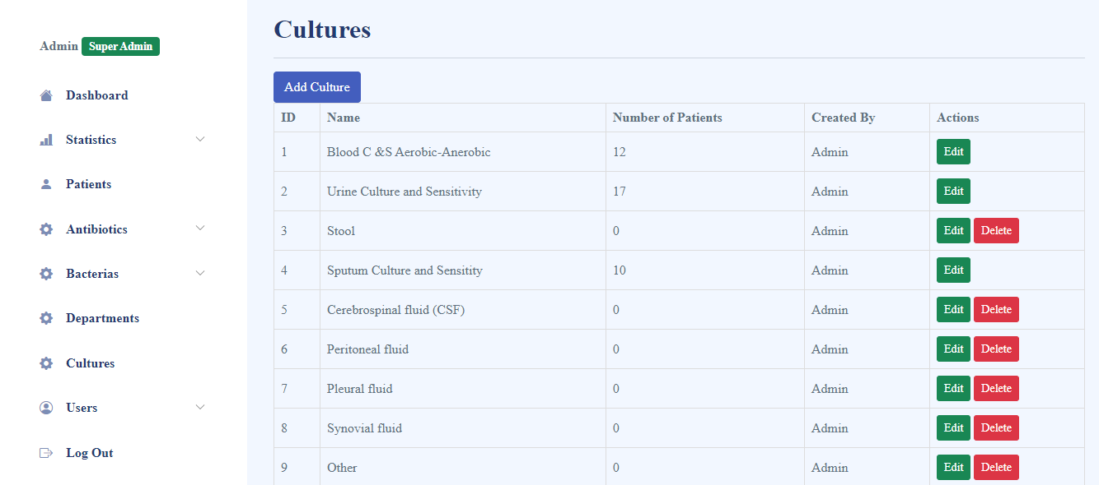

This Page Show Cultures Through Which I Know Which Type Of Bacteria Patient Have And Give Him Appropriate Antibiotic, Also I Can Add New Culture.

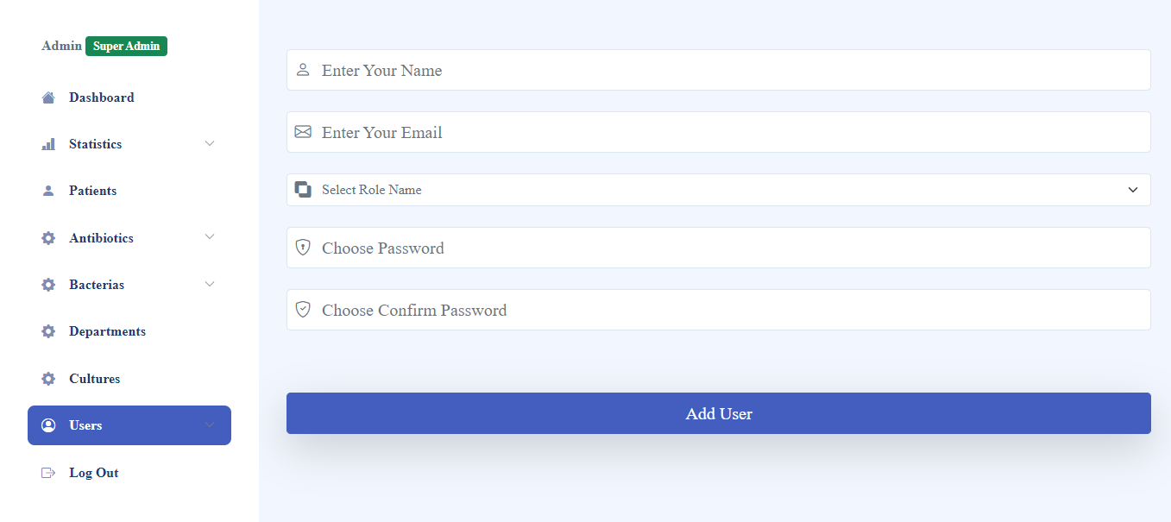

This Page Show The Process Of Adding New User To System ,And Select His Role On The System Which Data He Can Access And Which Not.

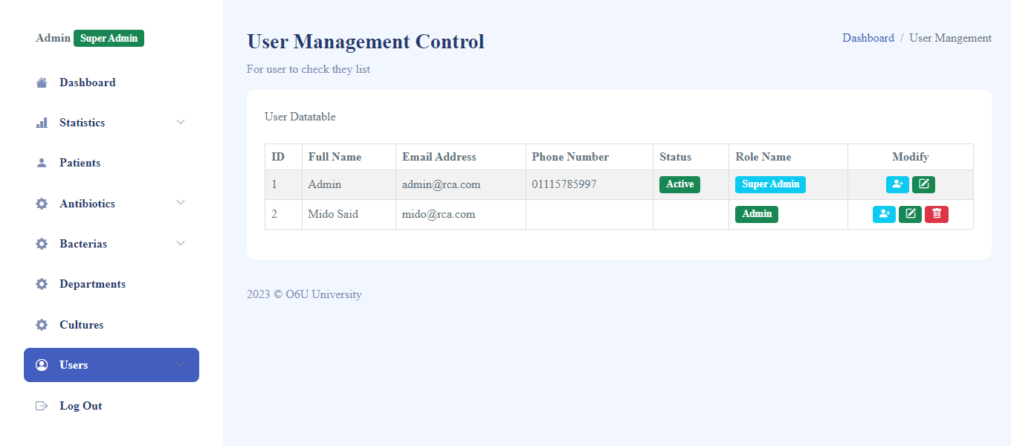

This Show If I Want To Modify User Data And Role Which He Have.

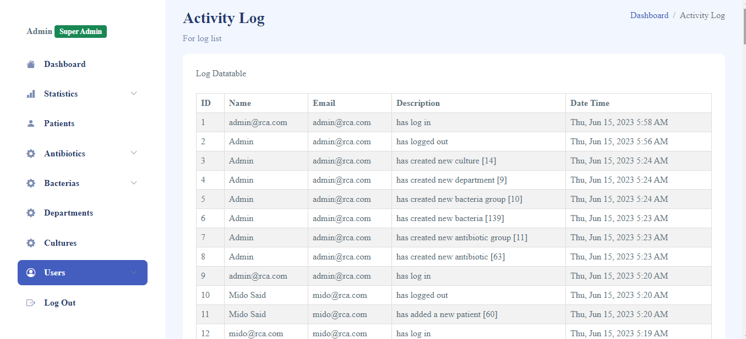

This Show Activity Of All Users On System.

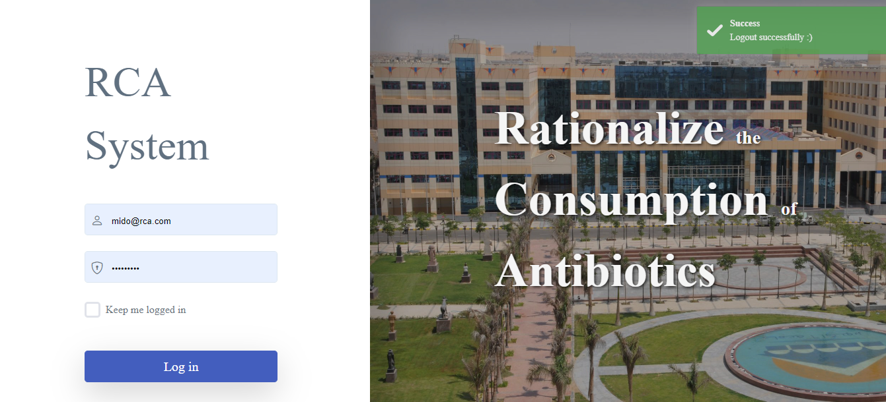

This Show Final Process on System Logging Out of System

Screen Shoots Of Mobile Application

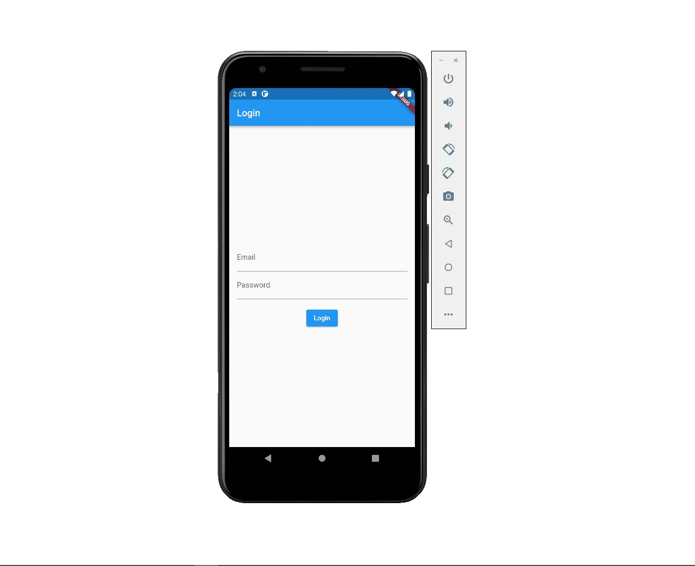

Loge In Page On Mobile Application

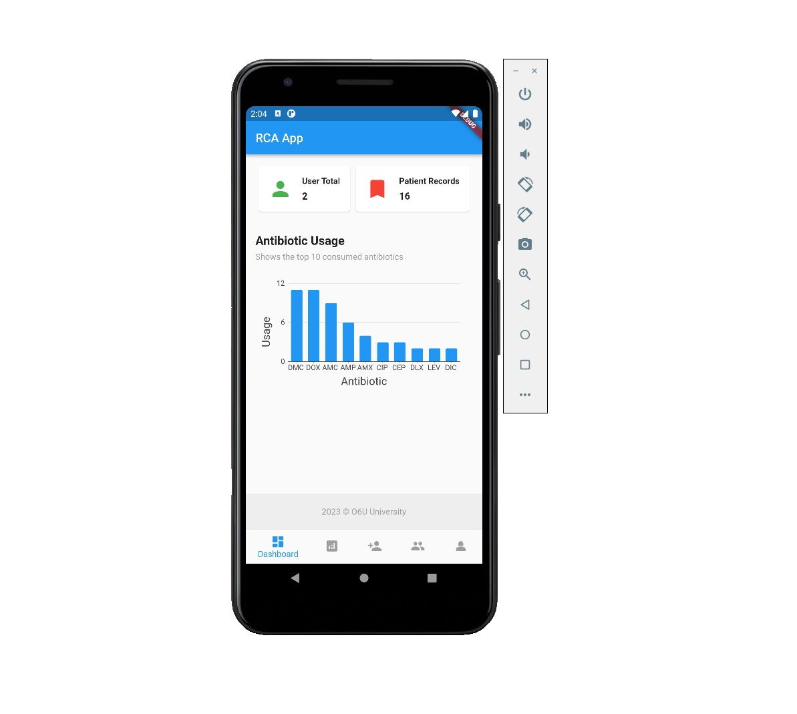
Dashboard Of Mobile Application Show Top 10 Consumed Antibiotics

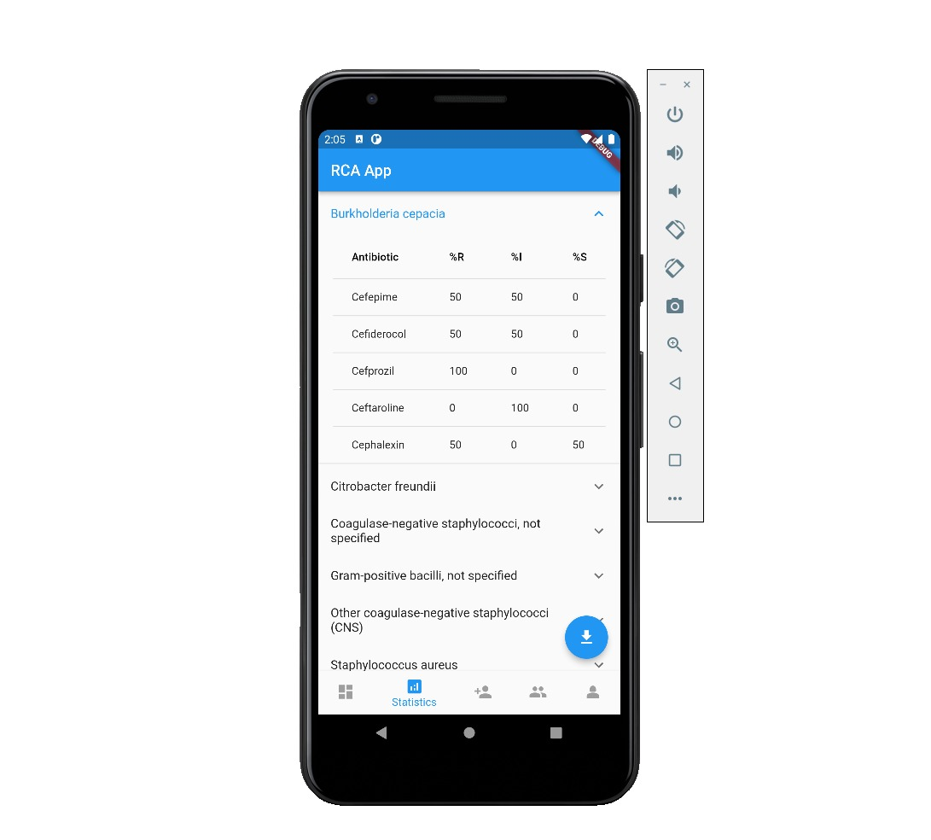
This Page Show Statistics Of Consumption

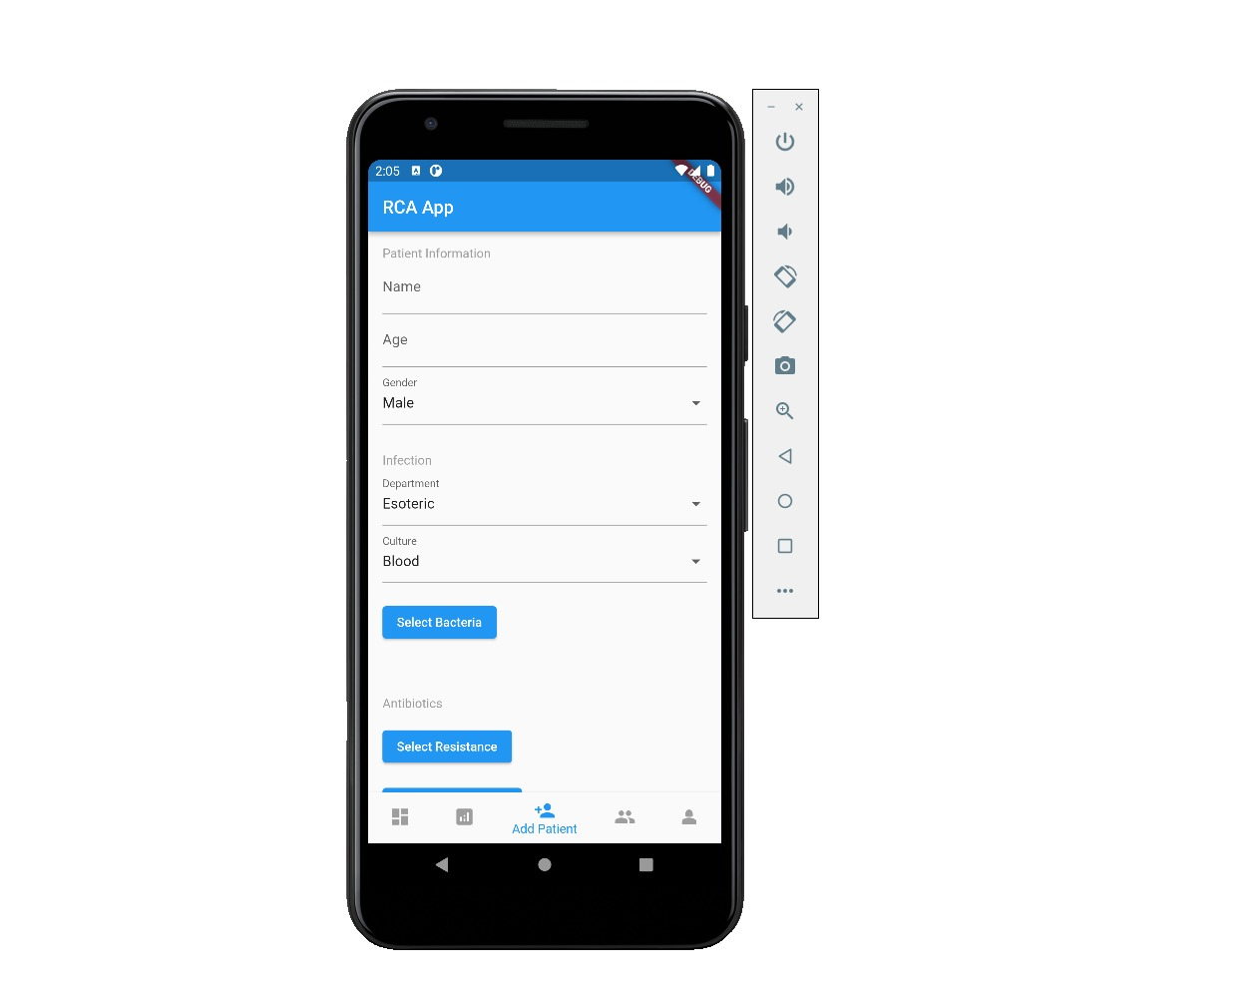
This Page Show Process Of Adding New Patient On The System

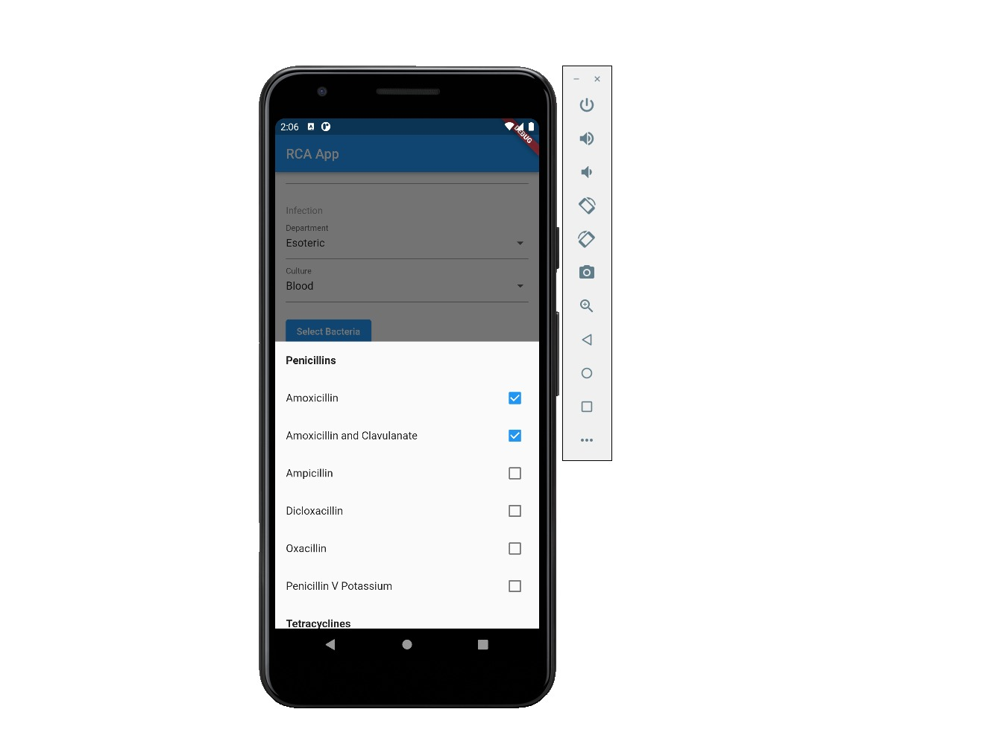
This Page Show Antibiotics

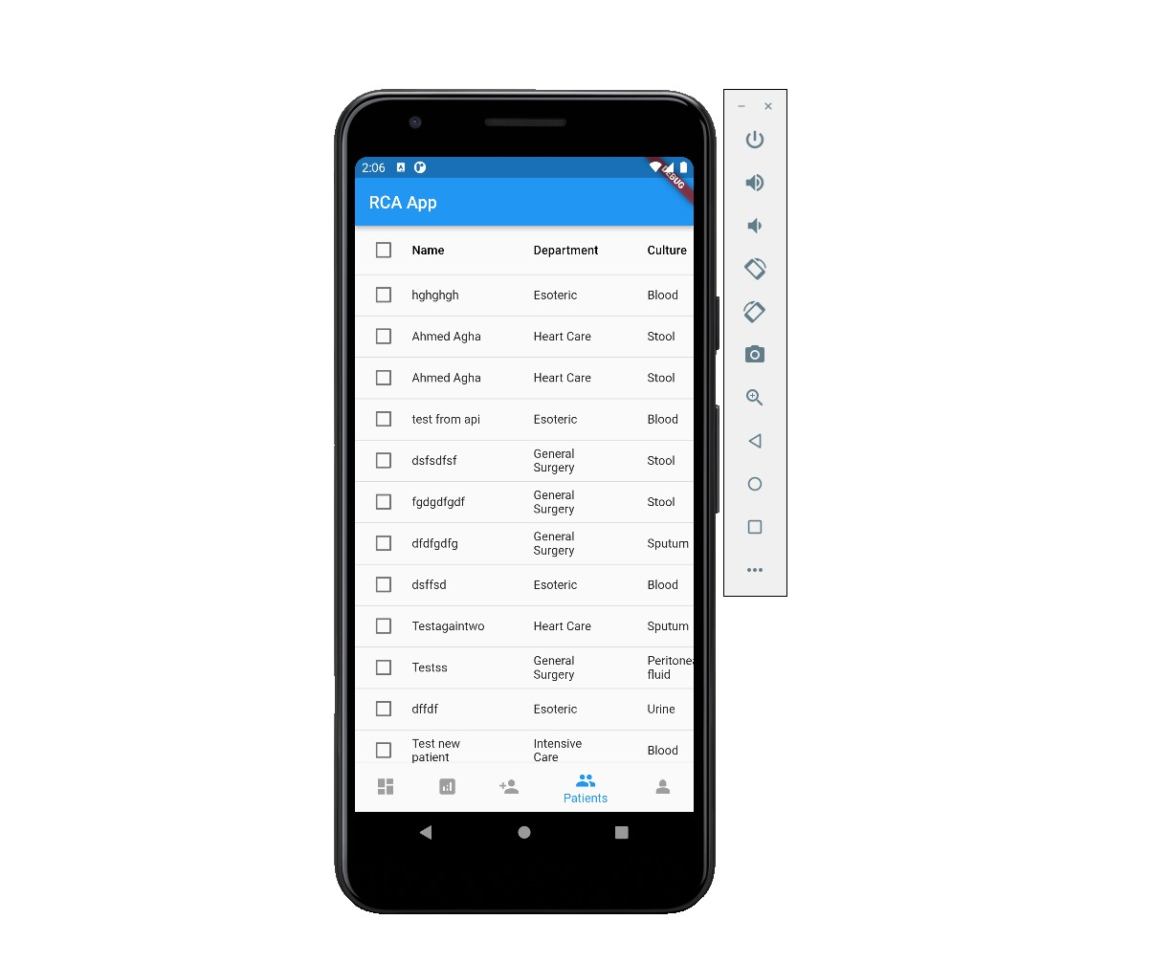
This Page Show Records Of All Patient On The System

Chapter Five

Conclusion & Future Work

5.1 Conclusion:
- Admin can create many users with different permissions.
- Users can Fill & Update patient’s forms.
- Admin or Authorized users can monitor consumption statistics.
- Admin or Authorized users can send system announcements.
- Admin can track user's activities.
- Admin can insert/update system data (Departments, Bacteria Types, Antibiotic Types).

5.2 Future Work:
future of rationalizing the consumption of antibiotics will likely involve a combination of technological advancements, increased public education, regulatory oversight, and collaborative efforts among stakeholders. By working together to address the problem of antibiotic resistance, we can help ensure that antibiotics remain effective in treating serious infections and protecting public health for generations to come.

- Increased global collaboration.
- Improved diagnostic tools.
- Development of new antibiotics.
- Develop IOS version from our project.
- Machine learning is booming in these days, there is an intent to use it for improving System to be more efficient and effective.

Appendices:

Front End Code:
RCA systems
System consists of 2 core components, first component is a backend system built with Laravel PHP with the help of Laravel Eloquent to create, migrate and manipulate database queries.
The first component is responsible for storing all data provided by the users and provide all the data needed for the users.
It’s also responsible for handling all type of requests done on the system.
The first component also controlled by an admin dashboard website to control all and track all resources on the system.
The second component is a MOBILE APPLICATION built with Flutter and it consumes API from the backend system.
Frontend tools
Our frontend code is written in HTML, JAVASCRIPT and BOOTSTRAP
to develop the frontend of the admin dashboard website.
Also we used FLUTTER widgets framework as a frontend in developing the mobile application.
Backend tools
We used Laravel PHP to develop and build the system’s models, controllers and interfaces.
With the help of Laravel Auth to secure and authenticate users and their requests.

Backend Models
- Patient
In summary, the “Patient” model class represents a patient entity in the system and provides methods to interact with related data, such as departments, cultures, bacteria, users, and antibiotics. It utilizes Laravel’s Eloquent ORM to define relationships and perform database queries.

Class Patient extends Model
{
use HasFactory;

protected $fillable = [
‘name’,
‘age’,
‘gender’,
‘department_id’,
‘culture_id’,
‘bacteria_id’,
‘user_id’
];

public function department()
{
return $this->belongsTo(Department::class);
}

public function culture()
{
return $this->belongsTo(Culture::class);
}

public function bacteria()
{
return $this->belongsTo(Bacteria::class);
}

public function user()
{
return $this->belongsTo(User::class);
}

public function antibiotics()
{
return $this->belongsToMany(Antibiotic::class)
->withPivot(‘resistance’, ‘intermediate’, ‘sensitive’);
}

public function resistance()
{
return DB::table(‘antibiotic_patient’)->where(‘patient_id’, $this->id)
->where(‘resistance_level’, ‘resistance’)
->pluck(‘antibiotic_id’)->toArray();
}
public function intermediate()
{
return DB::table(‘antibiotic_patient’)->where(‘patient_id’, $this->id)
->where(‘resistance_level’, ‘intermediate’)
->pluck(‘antibiotic_id’)->toArray();
}

public function sensitive()
{
return DB::table(‘antibiotic_patient’)->where(‘patient_id’, $this->id)
->where(‘resistance_level’, ‘sensitive’)
->pluck(‘antibiotic_id’)->toArray();
}
}

2. Antibiotic Model
The “Antibiotic” model class represents an antibiotic entity in the system. It provides relationships with an antibiotic group, patients, and a user. Additionally, it defines an accessor to retrieve the name of the antibiotic group and a custom query method for fetching a data table of antibiotics based on patient counts.

Class Antibiotic extends Model
{
use HasFactory;

protected $fillable = [‘name’, ‘abbreviation’, ‘antibiotic_group_id’, ‘user_id’];

protected $appends = [‘group_name’];

public function getGroupNameAttribute()
{
return $this->antibioticGroup->name;
}

public function antibioticGroup()
{
return $this->belongsTo(AntibioticGroup::class);
}

public function patients()
{
return $this->belongsToMany(Patient::class)
->withPivot(‘resistance_level’);
}

public function user()
{
return $this->belongsTo(User::class);
}

public function datatable()
{
$antibiotics = Antibiotic::withCount(‘patients’)
->orderBy(‘patients_count’, ‘desc’)
->limit(10)
->get();
return $antibiotics;
}
}

3. Bacteria Model
In summary, the “Bacteria” model class represents a bacteria entity in the system. It provides relationships with a bacteria group, patients, and a user. Additionally, it defines an accessor to retrieve the name of the bacteria group.

Class Bacteria extends Model
{
use HasFactory;
protected $fillable = [
‘name’,
‘user_id’,
‘bacteria_group_id’
];

protected $appends = [‘group_name’];

public function getGroupNameAttribute()
{
return $this->group->name;
}

public function group()
{
return $this->belongsTo(BacteriaGroup::class);
}

public function patients()
{
return $this->hasMany(Patient::class);
}
public function user()
{
return $this->belongsTo(User::class);
}
}

4. Department Model
In summary, the “Department” model class represents a department entity in the system. It provides relationships with patients and a user. The model allows you to retrieve the patients associated with a department and determine the user who created the department.

Class Department extends Model
{
protected $fillable = [‘name’, ‘user_id’];

public function patients()
{
return $this->hasMany(Patient::class);
}

public function user()
{
return $this->belongsTo(User::class);
}
}

5. Culture Model
In summary, the “Culture” model class represents a culture entity in the system. It provides relationships with patients and a user. The model allows you to retrieve the patients associated with a culture and determine the user who created the culture.
class Culture extends Model
{
protected $fillable = [‘name’, ‘user_id’];

public function patients()
{
return $this->hasMany(Patient::class);
}

public function user()
{
return $this->belongsTo(User::class);
}
}
6. User Model
In summary, the “User” model class represents a user entity in the system, with authentication capabilities. It provides a relationship with a role and defines fillable attributes, hidden attributes, and cast attributes. Each role has different permissions starting from Super admin to normal user. Where super admin has all permissions on the system and normal user has only the permission to insert patients.
class User extends Authenticatable
{
use HasFactory, Notifiable;
use LockableTrait;

protected $fillable = [
‘name’,
‘email’,
‘role_name’,
‘password’,
];

protected $hidden = [
‘password’,
‘remember_token’,
];

protected $casts = [
‘email_verified_at’ => ‘datetime’,
];

public function role(): BelongsTo
{
return $this->belongsTo(Role::class);
}

}

System Controllers
In summary provide insert, update and delete functionality to all system resources such as users, patients, antibiotics, bacteria and statistics data.

1.Patient Controller
class PatientController extends Controller
{
public function index(Request $request)
{
$patients = Patient::with([‘department’, ‘culture’, ‘bacteria’])
->orderBy(‘created_at’, ‘desc’);

// Filter by search query
if ($request->has(‘search’)) {
$searchTerm = $request->input(‘search’);
$patients->where(function ($query) use ($searchTerm) {
$query->where(‘name’, ‘LIKE’, ‘%’ . $searchTerm . ‘%’);
});
}

$patients = $patients->paginate(10);
return view(‘patients.index’, compact(‘patients’));
}

public function create()
{
// Retrieve all necessary data for the form
$departments = Department::all();
$cultures = Culture::all();
$bacteriaGroups = BacteriaGroup::all();
$antibioticGroups = AntibioticGroup::all();

return view(
‘patients.create’,
compact(
‘departments’,
‘cultures’,
‘bacteriaGroups’,
‘antibioticGroups’
)
);
}

public function store(Request $request)
{
$validatedData = $request->validate([
‘name’ => ‘required’,
‘age’ => ‘required|integer’,
‘gender’ => ‘required’,
‘department_id’ => ‘required|exists:departments,id’,
‘culture_id’ => ‘required|exists:cultures,id’,
‘bacteria_id’ => ‘required|exists:bacterias,id’,
]);

// Create the patient
$patient = new Patient();
$patient->name = $request->name;
$patient->age = $request->age;
$patient->gender = $request->gender;
$patient->department_id = $request->department_id;
$patient->culture_id = $request->culture_id;
$patient->bacteria_id = $request->bacteria_id;
$patient->user_id = Auth::user()->id;
$patient->save();

// Attach the antibiotics with their respective resistances, intermediate and sensitivities
$antibioticData = array();

foreach ($request->resistance as $r) {
// $antibioticResistanceData[(int)$antibioticId][‘resistance_level’] = ‘resistance’;
$antibioticIds = explode(‘,’, $r);
if ($antibioticIds[0] != “”) {

foreach ($antibioticIds as $id) {
$antibioticData[] = [
‘antibiotic_id’ => (int) $id, ‘resistance_level’ => ‘resistance’
];
}
}
}

foreach ($request->intermediate as $i) {
$antibioticIds = explode(‘,’, $i);
if ($antibioticIds[0] != “”) {

foreach ($antibioticIds as $id) {
$antibioticData[] = [

‘antibiotic_id’ => (int)$id, ‘resistance_level’ => ‘intermediate’
];
}
}
}

foreach ($request->sensitive as $s) {
$antibioticIds = explode(‘,’, $s);
if ($antibioticIds[0] != “”) {
foreach ($antibioticIds as $id) {
$antibioticData[] = [
‘antibiotic_id’ => (int)$id, ‘resistance_level’ => ‘sensitive’
];
}
}
}

$patient->antibiotics()->sync($antibioticData);

$dt = Carbon::now();
$todayDate = $dt->toDayDateTimeString();
$activityLog = [
‘name’ => Auth::user()->name,
‘email’ => Auth::user()->email,
‘description’ => ‘has added a new patient [‘ . $patient->id . ‘]’,
‘date_time’ => $todayDate,
‘created_at’ => Carbon::now(),
];

DB::table(‘activity_logs’)->insert($activityLog);
Toastr::success(‘Patient has been created successfully!’, ‘Success’);

return redirect()->route(‘patients.index’);
}

public function show(Patient $patient)
{
return view(‘patients.show’, compact(‘patient’));
}

public function edit(Patient $patient)
{
// Retrieve all necessary data for the form
$departments = Department::all();
$cultures = Culture::all();
$bacteriaGroups = BacteriaGroup::all();
$antibioticGroups = AntibioticGroup::all();

return view(
‘patients.edit’,
compact(‘patient’, ‘departments’, ‘cultures’, ‘bacteriaGroups’, ‘antibioticGroups’)
);
}

public function update(Request $request, Patient $patient)
{
// Validate the input data
$validatedData = $request->validate([
‘name’ => ‘required’,
‘age’ => ‘required|integer’,
‘gender’ => ‘required’,
‘department_id’ => ‘required|exists:departments,id’,
‘culture_id’ => ‘required|exists:cultures,id’,
‘bacteria_id’ => ‘required|exists:bacterias,id’,
]);

// Update the patient
$patient->name = $request->name;
$patient->age = $request->age;
$patient->gender = $request->gender;
$patient->department_id = $request->department_id;
$patient->culture_id = $request->culture_id;
$patient->bacteria_id = $request->bacteria_id;
$patient->update();

$patient->antibiotics()->detach();

$antibioticData = array();

foreach ($request->resistance as $r) {
$antibioticIds = explode(‘,’, $r);
if ($antibioticIds[0] != “”) {

foreach ($antibioticIds as $id) {
$antibioticData[] = [‘antibiotic_id’ => (int)$id, ‘resistance_level’ => ‘resistance’];
}
}
}

foreach ($request->intermediate as $i) {
$antibioticIds = explode(‘,’, $i);
if ($antibioticIds[0] != “”) {
foreach ($antibioticIds as $id) {
$antibioticData[] = [‘antibiotic_id’ => (int)$id, ‘resistance_level’ => ‘intermediate’];
}
}
}

foreach ($request->sensitive as $s) {
$antibioticIds = explode(‘,’, $s);
if ($antibioticIds[0] != “”) {
foreach ($antibioticIds as $id) {
$antibioticData[] = [‘antibiotic_id’ => (int)$id, ‘resistance_level’ => ‘sensitive’];
}
}
}

$patient->antibiotics()->sync($antibioticData);

$dt = Carbon::now();
$todayDate = $dt->toDayDateTimeString();
$activityLog = [
‘name’ => Auth::user()->name,
‘email’ => Auth::user()->email,
‘description’ => ‘has updated patient [‘ . $patient->id . ‘] info’,
‘date_time’ => $todayDate,
‘created_at’ => Carbon::now(),
];
DB::table(‘activity_logs’)->insert($activityLog);
Toastr::success(‘Patient has been updated successfully!’, ‘Success’);
// Redirect to the index page with a success message
return redirect()->route(‘patients.index’);
}

public function destroy(Patient $patient)
{
// Delete the patient and detach all the associated antibiotics
$patient->antibiotics()->detach();
$patient->delete();

// Redirect to the index page with a success message
return redirect()->route(‘patients.index’)->with(‘success’, ‘Patient has been deleted successfully!’);
}

public function datatable(Patient $patient)
{
return Patient::all()->toArray();
}

public function APIcreate(Request $request)
{
$validatedData = $request->validate([
‘name’ => ‘required’,
‘age’ => ‘required|integer’,
‘gender’ => ‘required’,
‘departmentId’ => ‘required|exists:departments,id’,
‘cultureId’ => ‘required|exists:cultures,id’,
‘bacteriaId’ => ‘required|exists:bacterias,id’,
]);

// Create the patient
$patient = new Patient();
$patient->name = $request->name;
$patient->age = $request->age;
$patient->gender = $request->gender;
$patient->department_id = $request->departmentId;
$patient->culture_id = $request->cultureId;
$patient->bacteria_id = $request->bacteriaId;
$patient->user_id = $request->userId;
$patient->save();

// Attach the antibiotics with their respective resistances, intermediate and sensitivities
$antibioticData = array();

foreach ($request->resistanceIds as $r) {
// $antibioticResistanceData[(int)$antibioticId][‘resistance_level’] = ‘resistance’;
$antibioticIds = explode(‘,’, $r);
if ($antibioticIds[0] != “”) {

foreach ($antibioticIds as $id) {
$antibioticData[] = [‘antibiotic_id’ => (int)$id, ‘resistance_level’ => ‘resistance’];
}
}
}

foreach ($request->intermediateIds as $i) {
$antibioticIds = explode(‘,’, $i);
if ($antibioticIds[0] != “”) {
foreach ($antibioticIds as $id) {
$antibioticData[] = [‘antibiotic_id’ => (int)$id, ‘resistance_level’ => ‘intermediate’];
}
}
}

foreach ($request->sensitiveIds as $s) {
$antibioticIds = explode(‘,’, $s);
if ($antibioticIds[0] != “”) {
foreach ($antibioticIds as $id) {
$antibioticData[] = [‘antibiotic_id’ => (int)$id, ‘resistance_level’ => ‘sensitive’];
}
}
}

$patient->antibiotics()->sync($antibioticData);

$dt = Carbon::now();
$user = User::find($request->userId);
$todayDate = $dt->toDayDateTimeString();
$activityLog = [
‘name’ => $user->name,
‘email’ => $user->email,
‘description’ => ‘has added a new patient [‘ . $patient->id . ‘]’,
‘date_time’ => $todayDate,
‘created_at’ => Carbon::now(),
];

DB::table(‘activity_logs’)->insert($activityLog);

return response(‘created’, 201);
}

public function IndexForApp(Request $request)
{
$patients = Patient::with([‘department’, ‘culture’, ‘bacteria’])->orderBy(‘created_at’, ‘desc’);

// Filter by search query
if ($request->has(‘search’)) {
$searchTerm = $request->input(‘search’);
$patients->where(function ($query) use ($searchTerm) {
$query->where(‘name’, ‘LIKE’, ‘%’ . $searchTerm . ‘%’);
});
}

$patients = $patients->get();
return $patients;
}

function patientsRecordsForApp()
{
$patientRecords = Patient::all()->count();
$response = array(‘patientRecords’ => $patientRecords);
return json_encode($response);
}

}

2. Antibiotic Controller

class AntibioticController extends Controller
{
/**
* Display a listing of the resource.
*
* @return \Illuminate\Http\Response
*/
public function index()
{
$antibiotics = Antibiotic::all();
return view(‘antibiotics.index’, compact([‘antibiotics’]));
}

/**
* Show the form for creating a new resource.
*
* @return \Illuminate\Http\Response
*/
public function create()
{
$antibioticGroups = AntibioticGroup::all();
return view(‘antibiotics.create’, compact([‘antibioticGroups’]));
}

/**
* Store a newly created resource in storage.
*
* @param \Illuminate\Http\Request $request
* @return \Illuminate\Http\Response
*/

public function store(Request $request)
{
// Validate the input data
$validatedData = $request->validate([
‘name’ => ‘required|unique:antibiotics’,
‘abbreviation’ => ‘required’,
‘antibiotic_group_id’ => ‘required|exists:antibiotic_groups,id’,
]);

$antibiotic = Antibiotic::create([‘user_id’ => Auth::user()->id, …$validatedData]);

$dt = Carbon::now();
$todayDate = $dt->toDayDateTimeString();
$activityLog = [
‘name’ => Auth::user()->name,
‘email’ => Auth::user()->email,
‘description’ => ‘has created new antibiotic [‘ . $antibiotic->id . ‘]’,
‘date_time’ => $todayDate,
‘created_at’ => Carbon::now(),
];
DB::table(‘activity_logs’)->insert($activityLog);
Toastr::success(‘Antibiotic has been created successfully!’, ‘Success’);

return redirect()->route(‘antibiotics.index’);
}

/**
* Display the specified resource.
*
* @param int $id
* @return \Illuminate\Http\Response
*/
public function show($id)
{
//
}

/**
* Show the form for editing the specified resource.
*
* @param int $id
* @return \Illuminate\Http\Response
*/
public function edit($id)
{
$antibiotic = Antibiotic::find($id);
$antibioticGroups = AntibioticGroup::all();
return view(‘antibiotics.edit’, compact([‘antibiotic’, ‘antibioticGroups’]));
}

/**
* Update the specified resource in storage.
*
* @param \Illuminate\Http\Request $request
* @param int $id
* @return \Illuminate\Http\Response
*/
public function update(Request $request, $id)
{
// Validate the input data
$validatedData = $request->validate([
‘name’ => ‘required|unique:antibiotics’,
‘abbreviation’ => ‘required’,
‘antibiotic_group_id’ => ‘required|exists:antibiotic_groups,id’,
]);

$antibiotic = Antibiotic::find($id);
$antibiotic->name = $request->name;
$antibiotic->antibiotic_group_id = $request->antibiotic_group_id;
$antibiotic->update();

$dt = Carbon::now();
$todayDate = $dt->toDayDateTimeString();
$activityLog = [
‘name’ => Auth::user()->name,
‘email’ => Auth::user()->email,
‘description’ => ‘has updated antibiotic [‘ . $antibiotic->id . ‘] info’,
‘date_time’ => $todayDate,
‘created_at’ => Carbon::now(),
];
DB::table(‘activity_logs’)->insert($activityLog);
Toastr::success(‘Antibiotic has been updated successfully!’, ‘Success’);

return redirect()->route(‘antibiotics.index’);
}

/**
* Remove the specified resource from storage.
*
* @param int $id
* @return \Illuminate\Http\Response
*/
public function destroy($id)
{
$antibiotic = Antibiotic::find($id);
$antibiotic->delete();
// Redirect to the index page with a success message
Toastr::success(‘Antibiotic has been deleted successfully!’, ‘Success’);
return redirect()->route(‘antibiotics.index’);
}

public function datatable()
{
$antibiotics = Antibiotic::withCount(‘patients’)
->orderBy(‘patients_count’, ‘desc’)
->limit(10)
->get();

return $antibiotics;
}

public function all()
{
return Antibiotic::all();
}

function antibioticUsageForApp()
{
$antibiotics = Antibiotic::select(‘abbreviation’)
->withCount(‘patients’)
->orderByDesc(‘patients_count’)
->limit(10)
->get()
->map(function ($antibiotic) {
return [
‘name’ => $antibiotic->abbreviation,
‘usage’ => $antibiotic->patients_count
];
})
->toArray();
$response = array(‘antibioticUsage’ => $antibiotics);
return json_encode($response);
}

}

3. Statistics Controller

class StatisticsController extends Controller
{

//
public function index(Request $request)
{
// Retrieve all departments, Bacteria groups
$departments = Department::all();
$bacteriaGroups = BacteriaGroup::all();

// Retrieve filter string parameters
$startDate = $request->query(‘date_from’);
$endDate = $request->query(‘date_to’);
$departmentId = $request->query(‘department’);
$gender = $request->query(‘gender’);
$bacteria = $request->query(‘bacteria’);

// Initialize query builder for statistics
$bacteriaStatistics = Bacteria::select(‘bacterias.name as bacteria_name’, ‘antibiotics.name as antibiotic_name’, DB::raw(‘count(case when antibiotic_patient.resistance_level = “resistance” then 1 end) as resistance_count’), DB::raw(‘count(case when antibiotic_patient.resistance_level = “intermediate” then 1 end) as intermediate_count’), DB::raw(‘count(case when antibiotic_patient.resistance_level = “sensitive” then 1 end) as sensitive_count’))
->join(‘patients’, ‘patients.bacteria_id’, ‘=’, ‘bacterias.id’)
->join(‘antibiotic_patient’, ‘antibiotic_patient.patient_id’, ‘=’, ‘patients.id’)
->join(‘antibiotics’, ‘antibiotics.id’, ‘=’, ‘antibiotic_patient.antibiotic_id’)
->groupBy(‘bacterias.name’, ‘antibiotics.name’);

// Apply filters to query builder
if ($departmentId) {
$bacteriaStatistics->where(‘department_id’, ‘=’, $departmentId);
}

if ($gender) {
$bacteriaStatistics->where(‘gender’, ‘=’, $gender);
}

if ($startDate) {
$bacteriaStatistics->where(
‘patients.created_at’,
‘>=’,
$startDate
);
}

if ($endDate) {
$bacteriaStatistics->where(
‘patients.created_at’,
‘<=’,
$endDate
);
}

if ($bacteria) {
$bacteriaStatistics->where(‘bacteria_id’, ‘=’, $bacteria);
}

// Execute query builder and retrieve statistics
$bacteriaStatistics = $bacteriaStatistics->get();

$emptyMessage = null;
if (count($bacteriaStatistics) == 0) {
$emptyMessage = ‘No Data found for your filter’;
}

// Group the statistics by bacteria name
$groupedStatistics = $bacteriaStatistics->groupBy(‘bacteria_name’);

// Convert the grouped statistics into an array of arrays
$statisticsArray = [];
foreach ($groupedStatistics as $bacteriaName => $statistics) {
$antibioticStatistics = [];
foreach ($statistics as $stat) {
$total = $stat->resistance_count + $stat->intermediate_count + $stat->sensitive_count;
$resistancePercent = $total > 0 ? round($stat->resistance_count / $total * 100, 2) : 0;
$intermediatePercent = $total > 0 ? round($stat->intermediate_count / $total * 100, 2) : 0;
$sensitivePercent = $total > 0 ? round($stat->sensitive_count / $total * 100, 2) : 0;
$antibioticStatistics[] = [
‘antibiotic_name’ => $stat->antibiotic_name,
‘resistance_percent’ => $resistancePercent,
‘intermediate_percent’ => $intermediatePercent,
‘sensitive_percent’ => $sensitivePercent,
];
}
$statisticsArray[] = [
‘bacteria_name’ => $bacteriaName,
‘antibiotic_statistics’ => $antibioticStatistics,
];
}

// Sort the statistics array by bacteria name
usort($statisticsArray, function ($a, $b) {
return strcmp($a[‘bacteria_name’], $b[‘bacteria_name’]);
});

// return $statisticsArray;
return view(‘statistics/index’, compact([‘statisticsArray’, ‘departments’, ‘bacteriaGroups’, ‘emptyMessage’]));
}
public function indexForApp(Request $request)
{
// Retrieve all departments, Bacteria groups
$departments = Department::all();
$bacteriaGroups = BacteriaGroup::all();

// Retrieve filter string parameters
$startDate = $request->query(‘date_from’);
$endDate = $request->query(‘date_to’);
$departmentId = $request->query(‘department’);
$gender = $request->query(‘gender’);
$bacteria = $request->query(‘bacteria’);

// Initialize query builder for statistics
$bacteriaStatistics = Bacteria::select(‘bacterias.name as bacteria_name’, ‘antibiotics.name as antibiotic_name’, DB::raw(‘count(case when antibiotic_patient.resistance_level = “resistance” then 1 end) as resistance_count’), DB::raw(‘count(case when antibiotic_patient.resistance_level = “intermediate” then 1 end) as intermediate_count’), DB::raw(‘count(case when antibiotic_patient.resistance_level = “sensitive” then 1 end) as sensitive_count’))
->join(‘patients’, ‘patients.bacteria_id’, ‘=’, ‘bacterias.id’)
->join(‘antibiotic_patient’, ‘antibiotic_patient.patient_id’, ‘=’, ‘patients.id’)
->join(‘antibiotics’, ‘antibiotics.id’, ‘=’, ‘antibiotic_patient.antibiotic_id’)
->groupBy(‘bacterias.name’, ‘antibiotics.name’);

// Apply filters to query builder
if ($departmentId) {
$bacteriaStatistics->where(‘department_id’, ‘=’, $departmentId);
}

if ($gender) {
$bacteriaStatistics->where(‘gender’, ‘=’, $gender);
}

if ($startDate) {
$bacteriaStatistics->where(
‘patients.created_at’,
‘>=’,
$startDate
);
}

if ($endDate) {
$bacteriaStatistics->where(
‘patients.created_at’,
‘<=’,
$endDate
);
}

if ($bacteria) {
$bacteriaStatistics->where(‘bacteria_id’, ‘=’, $bacteria);
}

// Execute query builder and retrieve statistics
$bacteriaStatistics = $bacteriaStatistics->get();

$emptyMessage = null;
if (count($bacteriaStatistics) == 0) {
$emptyMessage = ‘No Data found for your filter’;
}

// Group the statistics by bacteria name
$groupedStatistics = $bacteriaStatistics->groupBy(‘bacteria_name’);

// Convert the grouped statistics into an array of arrays
$statisticsArray = [];
foreach ($groupedStatistics as $bacteriaName => $statistics) {
$antibioticStatistics = [];
foreach ($statistics as $stat) {
$total = $stat->resistance_count + $stat->intermediate_count + $stat->sensitive_count;
$resistancePercent = $total > 0 ? round($stat->resistance_count / $total * 100, 2) : 0;
$intermediatePercent = $total > 0 ? round($stat->intermediate_count / $total * 100, 2) : 0;

$sensitivePercent = $total > 0 ? round($stat->sensitive_count / $total * 100, 2) : 0;
$antibioticStatistics[] = [
‘antibiotic_name’ => $stat->antibiotic_name,
‘resistance_percent’ => $resistancePercent,
‘intermediate_percent’ => $intermediatePercent,
‘sensitive_percent’ => $sensitivePercent,
];
}
$statisticsArray[] = [
‘bacteria_name’ => $bacteriaName,
‘antibiotic_statistics’ => $antibioticStatistics,
];
}

// Sort the statistics array by bacteria name
usort($statisticsArray, function ($a, $b) {
return strcmp($a[‘bacteria_name’], $b[‘bacteria_name’]);
});
return $statisticsArray;
}
public function exportPDF(Request $request)
{
$statisticsArray = json_decode(urldecode($request->statisticsArray), true);

$pdf = app(‘dompdf.wrapper’)->loadView(‘statistics.export’, compact(‘statisticsArray’));

return $pdf->download(‘antibiotic-statistics.pdf’);
}
}

System API
These routes define various endpoints for different functionalities of the application, allowing clients to interact with the API and perform actions such as authentication, patient management, antibiotic management, statistics retrieval, and user management.

<?php
use Illuminate\Http\Request;
use Illuminate\Support\Facades\Route;

Route::prefix(‘v1’)->group(function () {
Route::post(‘/login’, [AuthController::class, ‘login’]);
Route::post(‘/logout’, [AuthController::class, ‘logoutFromApp’]);
Route::get(‘/patients’, [PatientController::class, ‘indexForApp’]);
Route::get(‘/patientsDatatable’, [PatientController::class, ‘datatable’]);
Route::get(‘/antibioticsDatatable’, [AntibioticController::class, ‘datatable’]);
Route::get(‘/statistics’, [StatisticsController::class, ‘indexForApp’]);
Route::get(‘/antibioticGroups’, [AntibioticGroupController::class, ‘all’]);
Route::get(‘/antibiotics’, [AntibioticController::class, ‘all’]);
Route::get(‘/antibioticDatatable’, [AntibioticController::class, ‘datatable’]);
Route::get(‘/departments’, [DepartmentController::class, ‘all’]);
Route::get(‘/bacteria’, [BacteriaController::class, ‘all’]);
Route::get(‘/bacteriaGroups’, [BacteriaGroupController::class, ‘all’]);
Route::get(‘/cultures’, [CultureController::class, ‘all’]);
Route::post(‘/createPatient’, [PatientController::class, ‘APIcreate’]);
Route::get(‘/totalUsers’, [UserManagementController::class, ‘totalUsersForApp’]);
Route::get(‘/patientsRecords’, [PatientController::class, ‘patientsRecordsForApp’]);
Route::get(‘/antibioticUsage’, [AntibioticController::class, ‘antibioticUsageForApp’]);
});

System Packages and Addons

“devDependencies”: {
“axios”: “^0.19”,
“bootstrap”: “^4.0.0”,
“cross-env”: “^7.0”,
“jquery”: “^3.2”,
“aravel-mix”: “^5.0.1”,
“lodash”: “^4.17.19”,
“popper.js”: “^1.12”,
“resolve-url-loader”: “^2.3.1”,
“sass”: “^1.20.1”,
“sass-loader”: “^8.0.0”,
“select2”: “^4.1.0-rc.0”,
“vue”: “^2.5.17”,
“vue-template-compiler”: “^2.6.10”
},
“dependencies”: {
“datepicker”: “^0.0.0”
}

References :

- PHP-https://www.php.net/

- HTML-https://html.com/

- CSS- https://developer.mozilla.org/en-US/

- Java Script - https://www.javascript.com/

- Bootstrap- https://getbootstrap.com/

- GitHub- https://github.com/

- jQuery- https://jquery.com/

- Laravel- https://laravel.com/

- React- https://react.dev/

- My SQL- https://www.mysql.com/

- Flutter- https://flutter.dev/

- W3 School- https://www.w3schools.com/

- Stack Over Flow- https://stackoverflow.com/

- WHO- https://whonet.org/

ملخص المشروع

تعتبر المضادات الحيوية من الأدوية الهامة لعلاج الالتهابات البكتيرية. ومع ذلك ، فقد أدى الإفراط في استخدامها وإساءة استخدامها إلى ظهور البكتيريا المقاومة للمضادات الحيوية ، والتي تشكل تهديدًا كبيرًا للصحة العامة العالمية.

يعد ترشيد استهلاك المضادات الحيوية أمرًا ضروريًا للحفاظ على فعاليتها وضمان توافرها للأجيال القادمة. سنحقق ذلك من خلال نظام التطبيق والموقع الإلكتروني الذي يتضمن تحسين استخدام المضادات الحيوية من خلال ممارسات الوصفات المناسبة والمراقبة وتطوير علاجات بديلة

كلية نظم المعلومات وعلوم الحاسب 6 اكتوبر جامعة

مشروع التخرج

نظام ترشيد استهلاك المضادات الحيوية

أعد بواسطة
اسماء الطلاب القسم
محمد سعيد عبدالفتاح علوم حاسب
احمد محمد اسماعيل علوم حاسب
راضي محمد راضي علوم حاسب
عرفه احمد سالم نظم معلومات
علي احمد علي نظم معلومات
علاء عبدالله توفيق نظم معلومات

تحت إشراف
دكتور مهندس/ سامي السيد المقدم الدكتور/ عبدالرحمن الاخضر

الهيئة المعاونة
م. / حمد رشاد
يونيو ٢٠٢٣

